The Twenty-First Sunday after Pentecost
contemporary service
October 25, 2026 – 9:00am
_______________________________________

Call to Worship Video

Welcome and Announcements

The Bidding Prayer

*Opening Song

Our Prayers

*A Song of Praise and Preparation

Our Worship with Gifts of Tithes and Offerings
The Call
The Prayer of Dedication
Special Music

The Scripture Lesson
Matthew 5:38-47

The Sermon
Being Sermon on the Mount Christians
Part 16: Jesus Takes Us Deeper

*Closing Song

*Benediction

*Please stand as you are able

Jazze Palmer, Musician

the Twenty-First Sunday after Pentecost
traditional service
October 25, 2026 - 11:15 AM
PREPARATION for WORSHIP
The Prelude Prelude by Chopin

The Choral Introit

Welcome to Worship
(We bid special welcome to our guests today and encourage you to complete
a visitor’s card as found in the pew. We would be glad to contact you if you
wish. Thank you for being with us as we worship God.)

WORSHIP through PRAISE
The Call to Worship “Change My Heart, O God”
(See Screen)
The Bidding Prayer

*The Hymn of Praise “Holy, Holy, Holy” No. 64

WORSHIP through PRAYER
*Our Call to Prayer and Praise (by James Ward)
Leader: What is salt without its flavor? What is light you
cannot see?
People: Or a ship without a rudder? Without fruit, what is a
tree?
Leader: Jesus said they're good for nothing, and he gave a
warning call:
People: If we speak and then do nothing, we do not have faith
at all.
Leader: We believe our true salvation comes by grace through
faith alone;
All: But true faith results in action, by our deeds we make
love known to all.

The Prayer of Invocation
Eternal giver of grace, you come into our worship to welcome
us back to you. May we here experience the good news of your
radical forgiveness so that we are moved to extraordinary acts
of discipleship, all for the sake of your Son, our Lord. Amen.

A Time of Silent Prayer and Meditation

Our Prayer for Greater Discipleship (A Quaker Prayer)
Be conscious as you pray with palms up and arms
outstretched:
Part I: God, you have given my life into my hands. I give it back
to you. My time, my property, my life itself ... knowing
it is only an instant compared to my life with you in
eternity.
Part II: Father, to you I release the cares and concerns of this
world, knowing you loved me enough to give your only
Son in my behalf. I'm a sinner in need of a Savior and,
once again, I accept what you have done for me as
sufficient. In Jesus' name. Amen.

The Hymn of Prayer “Seek Ye First” No. 405

The Prayers of Our People, Pastoral Prayer, and Lord’s Prayer

Morning Anthem "Wonderful, Merciful Savior"

WORSHIP with GIFTS of TITHES and OFFERINGS
The Call
The Prayer of Dedication
The Offertory Where Cross the Crowded Ways of Life

WORSHIP through PROCLAMATION OF THE WORD
The Scripture Lesson Matthew 5:38-47

The Hymn of Preparation “I Love Thy Kingdom, Lord” No. 540

The Sermon Being Sermon on the Mount Christians
Part 16: Jesus Takes Us Deeper

*The Hymn of Dedication “The Lord’s Prayer Malotte

*The Benediction and Postlude Autumn
Jackie Linsey, Organist


The Altar Flowers are presented to
the Glory of God by Yorkshire Church

Veterans Cards
Gail Davis is collecting cards for Veterans. Veteran specific cards can be purchased at the Dollar Store. If you are interested in participating, please put cards on the table next to the narthex by Nov 8th. Please see Gail with questions.

Angel Tree
On November 1st the Angel Tree will be in the narthex.
On the tree will be angels from New Life for Mothers and Children. Each angel will have wish list items on them. Choose an angel, purchase the gift, wrap and put the angel tag on the outside of the gift to make someone’s Christmas special! All wrapped gifts need to be returned to the church by Dec 15th.

Children’s Bible Sponsors
Beginning Nov 1st we will be looking for sponsors of Bibles for our preschool children. Each Bible is $10, chose a tag from the board and put your $10 in an envelope. We will purchase Bibles in bulk using the monetary donations received. We appreciate your support!

Annual Church Conference
Our Annual Church Conference will be held on Saturday, November 7th at 10am at Calvary United Methodist Church, 11 North Richland Ave, York. All members of Yorkshire Church are welcome to attend.

Pastor Roger vacation
Pastor Roger will be on vacation from Nov 1st (after church service) thru Nov 19th. During that time the following Pastors will be filling in:
November 8th – Rev. Dr. Edwin Zeiders
November 15th – Pastor Megan Barnett
We wish Pastor Roger a safe and enjoyable vacation!
EVENTS THIS WEEK
Sunday
Youth Group – 5:30pm

Monday
Women’s Bible Study – 7pm

Wednesday
“Men at the Sixes” @6am - Fellowship Hall
Bible Study @6pm – Youth Room
The Well @7:15pm – Room 206

Thursday
Prayer Breakfast @8am- Two Brothers Restaurant
Choir Rehearsal @6pm

UPCOMING EVENTS

Annual Church Conference
Nov 7th @10 – Calvary UM Church

Youth Group Retreat
Nov 13-15th Unite Fall Retreat

Hanging of the Greens
November 28th – 9-12pm

Thanksgiving Holiday
November 26&27 – Church Office Closed
Church Staff
Roger Mentzer, Pastor
Stacey Roache, Administrative Assistant
Matthew Hochmiller, Choir Director
Jackie Linsey, Organist
Beth Gross, Organist
Jazze Palmer, Contemporary Musician
Chris Bare, Custodian
Julie Mann, Preschool Director

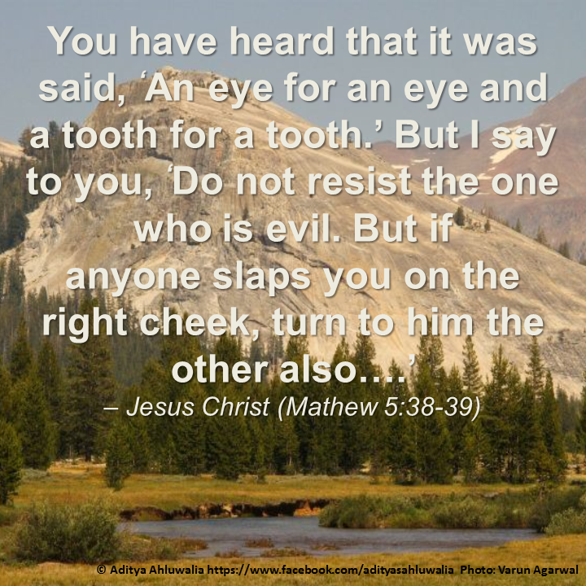

Yorkshire United Methodist Church
125 Edgewood Road
York, PA 17403
717-7554952
www.yorkshirechurch.org

Our Mission
Follow Jesus. Live His Word. Love Others.

