The Nineteenth Sunday after Pentecost
contemporary service
October 11, 2026 – 9:00am
_______________________________________

Call to Worship Video

Welcome and Announcements

The Bidding Prayer

*Opening Song

Our Prayers

*A Song of Praise and Preparation

Our Worship with Gifts of Tithes and Offerings
The Call
The Prayer of Dedication
Special Music

The Scripture Lesson
Matthew 5:31-32

The Sermon
Being Sermon on the Mount Christians
Part 14: Jesus Takes Us Deeper

*Closing Song

*Benediction

*Please stand as you are able

Jazze Palmer, Musician

the Nineteenth Sunday after Pentecost
traditional service
October 11, 2026 - 11:15 AM
PREPARATION for WORSHIP
The Prelude Autumn

The Choral Introit

Welcome to Worship
(We bid special welcome to our guests today and encourage you to complete
a visitor’s card as found in the pew. We would be glad to contact you if you
wish. Thank you for being with us as we worship God.)

WORSHIP through PRAISE
The Call to Worship “Shine, Jesus, Shine” (See Screen)

The Bidding Prayer

*The Hymn of Praise “All Praise to Thee” No. 166

*Our Affirmation of Faith “The Apostle’s Creed” No. 881

Our Call to Prayer and Praise Based on Psalm 119
Leader: Those who stay on course, walking steadily on the
road revealed by God, are blessed.
People: We are blessed by following God's instructions,
doing our best to seek God with all our hearts.
Leader: God has prescribed the right way to live, the way that
leads to health and happiness.
People: Help us, Lord, to keep to the course you set, walking
with steady steps all the way. Then we will not be
looking back over our lives with regrets.
Leader: Instead, we will have the comfort and joy of God's
companionship all our days.

A Prayer for Greater Discipleship (Unison)
Holy God, the way of the cross was a scandal 2,000 years ago,
and it is no less a scandal today. The cross calls us to lives of
humility in a world where pride, arrogance and self-promotion
are seen as virtues. The cross proclaims peace in the midst of
war, violence and abuse. It pleads for justice, assailing the
disparities between rich and poor, sick and well, hungry and full,
sheltered and homeless that we excuse as the status quo.

The cross bleeds love and cries mercy, and it asks us to live —
and to die — with the same love and mercy of Christ. Enable us,
Lord, by your power and grace, to give ourselves fully to what
the cross asks of us. For the sake of Christ, we pray. Amen.

A Time of Silent Prayer and Meditation

Our Prayer of Confession (Unison)
Our God, forgive us for failing to understand and accept the
great demands placed upon us by your love. We enlist in your
causes, but find ourselves losing interest. We promise to be
courageous, but find ourselves afraid. We want to be sensitive,
but find ourselves hard and callous. Forgive us; take our
limitations and turn them into possibilities for service. Have
mercy on us and grant us your peace. Amen.

The Hymn of Prayer “My Jesus, I Love Thee” No. 172

The Prayers of Our People, Pastoral Prayer, and Lord’s Prayer

Morning Anthem “Give Me Jesus”

WORSHIP with GIFTS of TITHES and OFFERINGS
The Call
The Prayer of Dedication
The Offertory This Is My Father’s World

WORSHIP through PROCLAMATION OF THE WORD
The Scripture Lesson Matthew 5:31-32

The Hymn of Preparation “O Spirit of the Living God” No. 539

The Sermon Being Sermon on the Mount Christians
Part 14: Jesus Takes Us Deeper

*The Hymn of Dedication “Stand Up and Bless the Lord” No. 662

*The Benediction and Postlude Fugue in F Major Bach
Jackie Linsey, Organist

The Altar Flowers are presented by Ben & Denise Bailey
in honor of our son, Tyler’s birthday on Oct 14th.

Preschool Sub Fundraiser
Sub orders are due this week on Oct 13th.

Yorkshire T-shirts
T-shirts are for sale in the narthex for $20/each.
This will be the last week they will be in the narthex, if you want a shirt after this time please reach out to the church office.

NorthEast Neighborhood
Due to Preschool regulations the table for donations to the NorthEast Neighborhood has been moved. Please put all donations on the table which is now in the narthex under the coat rack. Thank You!

REMINDER - Ernie Morgan’s Memorial
Ernie’s Memorial Service is set for this
Saturday, Oct 17th @ 11am

Zippy Beef Casseroles
We are looking for new volunteers for Zippy Beef Casseroles.
There are ingredients and a signup sheet
in the Narthex for November.
These need to be at the church by Oct 30th.

Youth Group Meals
Donations are needed for meals for the Youth Group.
Meals need to be at the church by 5:15pm each Sunday.
A sign-up sheet is in the narthex.
Please contact Joe Blackwood with questions.

Trunk or Treat – Oct 24th 10-12pm
There is a bin in the narthex for candy donations as well as a
sign-up sheet for those interested in
decorating their trunks and handing out candy!

Youth Group Retreats
The Youth Group will be on the following retreats:
Unite Fall Retreat – Nov 13-Nov 15, 2026
Zeteo Event – Jan 29-Jan 31, 2026
Please keep the youth and leaders
in your prayers for successful events.

Veterans Cards
Gail Davis is collecting cards for Veterans. Cards will be given to the VA Office and then delivered to the VA Hospital. Veteran specific cards can be purchased at the Dollar Store. If you are interested in participating, there will be a table placed in the hallway next to the narthex for cards to be placed by Nov 8th. Please see Gail with questions.


EVENTS THIS WEEK

Sunday
Youth Group – 5:30pm

Monday
Women’s Bible Study – 7pm

Wednesday
“Men at the Sixes” @6am - Fellowship Hall
Bible Study @6pm – Youth Room
The Well @7:15pm – Room 206

Thursday
Prayer Breakfast @8am- Two Brothers Restaurant
Choir Rehearsal @6pm

Saturday
Ernie Morgan’s Memorial @11am

UPCOMING EVENTS

Ernie Morgan’s Memorial Service
Oct 17th – 11am

Trunk or Treat
Oct 24th – 10-12pm

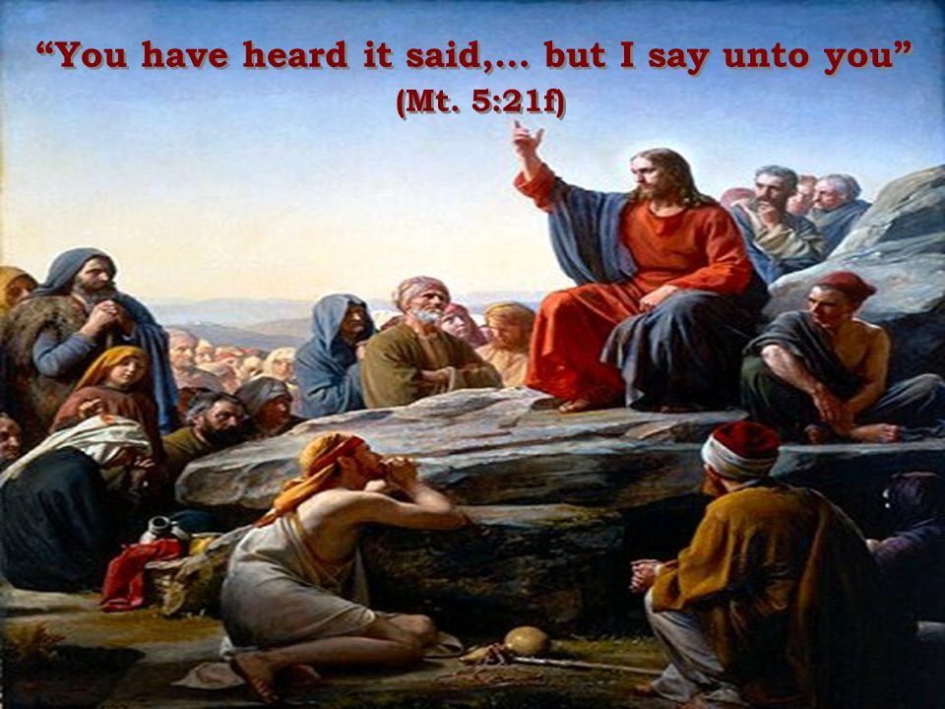

Yorkshire United Methodist Church
125 Edgewood Road
York, PA 17403
717-7554952
www.yorkshirechurch.org

Our Mission
Follow Jesus. Live His Word. Love Others.

