The Twenty-Third Sunday after Pentecost
All Saints Sunday
contemporary service
November 1, 2026 – 9:00am
_______________________________________

Call to Worship Video

Welcome and Announcements

The Bidding Prayer

*Opening Song

Our Prayers
Including Prayers In
The Remembrance of the Honored Dead

*A Song of Praise and Preparation

Our Worship with Gifts of Tithes and Offerings
The Call
The Prayer of Dedication
Special Music

The Scripture Lesson
Matthew 6:1-4

The Sermon
Being Sermon on the Mount Christians
Part 17: Ain’t I Great?

A Time with Our Children

The Sacrament of Holy Communion

*Closing Song

*Benediction

*Please stand as you are able

Jazze Palmer, Musician

the Twenty-Third Sunday after Pentecost
All Saints Sunday
traditional service
November 1, 2026 - 11:15 AM
PREPARATION for WORSHIP
The Prelude Trio On "My Shepherd Will Supply My Need"

The Choral Introit

Welcome to Worship
(We bid special welcome to our guests today and encourage you to complete
a visitor’s card as found in the pew. We would be glad to contact you if you
wish. Thank you for being with us as we worship God.)

WORSHIP through PRAISE
The Call to Worship “Give Thanks” Henry Smith
(See Screen)
The Bidding Prayer

*The Hymn of Praise “Ask Ye What Great Thing I Know” No. 163

Call to Prayer and Praise
Leader: Sooner or later, we take the plunge. Sooner or later,
we step out in faith.
People: Sooner or later, we reject the darkness and walk
towards the light. Sooner or later, we stand up for
Jesus. Lord make it true today in worship and praise.

The Prayer of Invocation
Loving and Holy God, gather us in, the haughty and proud, the
meek and the lowly, the saint and the sinner, the winner and the
loser. Gather us as one people who have come to realize that
you love us all and that you want us all in the kingdom of
heaven. Amen.

A Time of Silent Prayer and Meditation

A Prayer of Confession
Gracious God, at the season of the harvest, we realize that the year is waning, perhaps more quickly than we imagine. Perhaps it is time to take stock of our resolutions and dreams.
Where we have been successful as your people, we pray that
you will receive all the credit. Where we have fallen short we
pray that we will see in you a solution. We praise you for the
renewal of hope that follows a good harvest or even a
disappointing yield. This hope is possible because you are
constant in your mercy and love. Amen.

Words of Comfort, Assurance, and Instruction
(From Ephesians 1:13-14)
Leader: We have heard the word of truth, the gospel of our
salvation. May our hearts be marked by the seal of the
Holy Spirit, which is the pledge of our inheritance as
God’s own people – a people redeemed and fitted to
offer God’s praise.

The Hymn of Prayer “The Lord’s My Shepherd, I’ll Not Want”
No. 136

Prayers in Remembrance of the Honored Dead, The Prayers of
Our People, Pastoral Prayer

Morning Anthem “God is Love”

WORSHIP with GIFTS of TITHES and OFFERINGS
The Call
The Prayer of Dedication
The Offertory Morning Has Broken

WORSHIP through PROCLAMATION OF THE WORD
The Scripture Lesson Matthew 6:1-4

The Hymn of Preparation “How Can We Name a Love” No. 111

The Sermon Being Sermon on the Mount Christians
Part 17: Ain’t I Great?

The Sacrament of Holy Communion

*The Hymn of Dedication “Tis a Gift to be Simple”

*The Benediction and Postlude Festival On "For All The Saints"
Jackie Linsey, Organist

The Altar Flowers are presented in loving memory of
Norey Lucash.

We send heartfelt prayers to Fran Lucash
and his family during this most difficult time.

Norey was a blessing to all that knew her and
she will be deeply missed.

Norey’s Memorial Services
We continue to keep Fran and the entire family in our prayers. Norey’s memorial service is scheduled for Saturday, Nov 28th. Visitation will be from 10-11am and the service will be held immediately after.

Pastor Roger vacation
Pastor Roger will be on vacation beginning today thru Nov 19th. During that time the following Pastors will be filling in:
November 8th – Rev. Dr. Edwin Zeiders
November 15th – Pastor Megan Barnett

Annual Church Conference
Our Annual Church Conference will be held on Saturday, November 7th @10am at Calvary United Methodist Church, 11 North Richland Ave, York. All members of Yorkshire Church are welcome to attend.

Chemo Care Bags
If you’re interested in helping us stuff Chemo Care Bags, we will be meeting on Saturday, November 7th, at 9:00 AM in the Fellowship Hall. Because these care bags are going to patients who are immunocompromised, we kindly ask if you’re not feeling well, please stay home and support us in spirit! Please talk to Tiffany Ivie with any questions.

Veterans Cards
Gail Davis is collecting cards for Veterans. Veteran specific cards can be purchased at the Dollar Store. If you are interested in participating, please put cards on the table next to the narthex by Nov 8th. Please see Gail with questions.

Angel Tree
The angel tree is in the narthex! Angels on the tree are from New Life for Mothers and Children. Each angel has wish list. Choose an angel, purchase the gift, wrap and put the angel tag on the outside of the gift to make someone’s Christmas special! All wrapped gifts need to be returned to the church by Dec 15th.
Children’s Bible Sponsors
Beginning Nov 1st, we will be looking for sponsors of Bibles for our preschool children. Each Bible is $10, chose a tag from the board and put your $10 in an envelope. We will purchase Bibles in bulk using the monetary donations received. We appreciate your support!

EVENTS THIS WEEK

Sunday
Youth Group – 5:30pm

Monday
Women’s Bible Study – 7pm

Wednesday
“Men at the Sixes” @6am - Fellowship Hall
Bible Study @6pm – Youth Room
The Well @7:15pm – Room 206

Thursday
Prayer Breakfast @8am- Two Brothers Restaurant
Choir Rehearsal @6pm



UPCOMING EVENTS

Annual Church Conference
Nov 7th @ 10am

Youth Group Retreat
Nov 13-15th Unite Fall Retreat

Thanksgiving holiday
November 26&27 – Church Office Closed

Hanging of the Greens
November 28th – 1:30pm
Please note the time change!

Norey’s Memorial Service
November 28, 2026 10-11am visitation, service immediately after

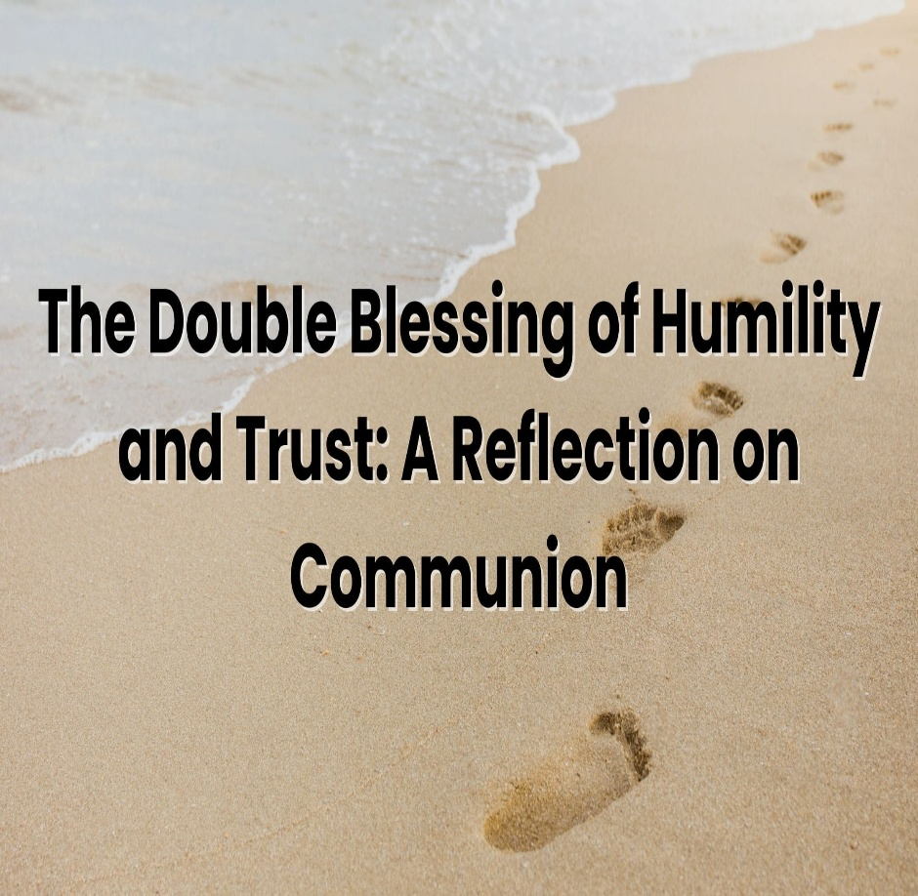

Yorkshire United Methodist Church
125 Edgewood Road
York, PA 17403
717-7554952
www.yorkshirechurch.org

Our Mission
Follow Jesus. Live His Word. Love Others.

