The Seventeenth Sunday after Pentecost
contemporary service
September 20, 2026 – 9:00am
_______________________________________

Call to Worship Video

Welcome and Announcements

The Bidding Prayer

*Opening Song

Our Prayers

*A Song of Praise and Preparation

Our Worship with Gifts of Tithes and Offerings
The Call
The Prayer of Dedication
Special Music

The Scripture Lesson
Matthew 5:27-30

The Sermon
Being Sermon on the Mount Christians
Part 13: Jesus Takes Us Deeper

*Closing Song

*Benediction

*Please stand as you are able

Jazze Palmer, Musician

the Seventeenth Sunday after Pentecost
traditional service
September 20, 2026 - 11:15 AM
PREPARATION for WORSHIP
The Prelude Recessional on "St. Anne"

Welcome to Worship
(We bid special welcome to our guests today and encourage you to complete
a visitor’s card as found in the pew. We would be glad to contact you if you
wish. Thank you for being with us as we worship God.)

WORSHIP through PRAISE
The Call to Worship “Shine, Jesus, Shine” (See Screen)

The Bidding Prayer

*The Hymn of Praise “The God of Abraham Praise” No. 116

Our Call to Prayer and Praise
Leader: Like a whisper that lures us to safety, strong as a shout
that bids us to come, Gentle as a prayer that eases our
worry, yet like a clear bell that rings out our name,
People: Your Word comes to us, Loving God. It calls us,
comforts us and urges us to depart from evil and do
good, to seek peace and pursue it.
Leader: O God, as you speak to us, open our hearts to hear you
and free our voices to praise you.

A Prayer for Greater Discipleship (Unison) From Martin Luther
Behold, Lord, an empty vessel that needs to be filled. My Lord,
fill it. I am weak in the faith; strengthen me. I am cold in love;
warm me and make me fervent, that my love may go out to my
neighbor. I do not have a strong and firm faith; at times I doubt
and am unable to trust you altogether. O Lord, help me.
Strengthen my faith and trust in you. In you I have sealed the
treasure of all I have. I am poor; you are rich and came to be
merciful to the poor. I am a sinner; you are upright. With me,
there is an abundance of sin; in you is the fullness of
righteousness. Therefore, I will remain with you of whom I can
receive, but to whom I may not give. Amen.

A Time of Silent Prayer and Meditation

Our Prayer of Confession (Responsively)
Leader: Loving God, you surround us in a warm embrace, and
in your love teach us how to love others.
People: In your Spirit, we ask for guidance and remind us
always of your compassion for all humankind. Help us
to keep our eyes and our lives focused on our perfect
guide in Jesus Christ.
Leader: Enable us to follow the teachings of Jesus above our
own way and will.
People: Help us, too, loving God, to work for growth in your
kingdom. Sometimes it is difficult to speak a word of
hope and help to those in need. With the
encouragement of your Spirit, may we be faithful
builders of your eternal kingdom.
Leader: In the name of Christ our Lord, Model, Guide and
Savior. Amen.

The Hymn of Prayer “Morning Has Broken” No. 145

The Prayers of Our People, Pastoral Prayer, and Lord’s Prayer

Morning Anthem "Let The Song Go Forth"

WORSHIP with GIFTS of TITHES and OFFERINGS
The Call
The Prayer of Dedication
The Offertory “O Perfect Love”

WORSHIP through PROCLAMATION OF THE WORD
The Scripture Lesson Matthew 5:27-30

The Hymn of Preparation “O Jesus I Have Promised”
No. 396
The Sermon Being Sermon on the Mount Christians
Part 13: Jesus Takes Us Deeper

*The Hymn of Dedication “I Am Thine, O Lord” No. 419

*The Benediction and Postlude 'Tis So Sweet to Trust in Jesus

Beth Gross, Organist



The Altar Flowers are presented by
Charlie & Janice Hoffman
thanking God for their
mutual birthday and anniversary
on September 22nd!

Pastor Roger will be on vacation Sept 21st-Oct 8th
Pastor Terry Robinson will be filling in on Sept 27th
Pastor Bud Bish will be filling in on Oct 4th

Youth Group
The Youth Group will reconvene today with a cookout at
The Blackwood’s house for the Youth and their families.

Yorkshire T-shirts
T-shirts are for sale in the narthex for $20/each. There are a variety of sizes available. If interested place your cash or check in the envelope and mark as t-shirt money.

Preschool Sub Fundraiser
The Preschool Sub Fundraiser starts today thru Oct 13th.
Order forms are in the narthex

Sound & Media Center
We are looking for volunteers for the Sound & Media Center, especially during the 11:15 service.
Please see Frank Herron or Al Mink
if you are interested in learning more!

Greeters Needed
We are in need of new Greeters for the 11:15 service.
If you can open a door, pass out bulletins and
smile at your friends, you are qualified.
Potential attendees need to see that same smiling face
to feel welcome at our church.
Please contact John Remsen for more information.

Trunk or Treat
There is a bin in the narthex for candy donations as well as a sign-up sheet for those interested in
decorating their trunks and handing out candy!

EVENTS THIS WEEK:

Sunday
Youth Group – 5:30pm

Monday
Preschool Sub Fundraiser begins
Women’s Bible Study – 7pm – Fellowship Hall

Wednesday
“Men at the Sixes” @6am - Fellowship Hall
Bible Study @6pm – Youth Room
The Well @7:15pm – Room 206

Thursday
Prayer Breakfast @8am- Two Brothers Restaurant
Choir Rehearsal – 6pm


UPCOMING EVENTS:

Ernie Morgan’s Memorial Service
Oct 17th @11am

Trunk or Treat
Oct 24th – 10-12pm

Church Staff
Roger Mentzer, Pastor
Stacey Roache, Administrative Assistant
Matthew Hochmiller, Choir Director
Jackie Linsey, Organist
Beth Gross, Organist
Jazze Palmer, Contemporary Musician
Chris Bare, Custodian
Julie Mann, Preschool Director

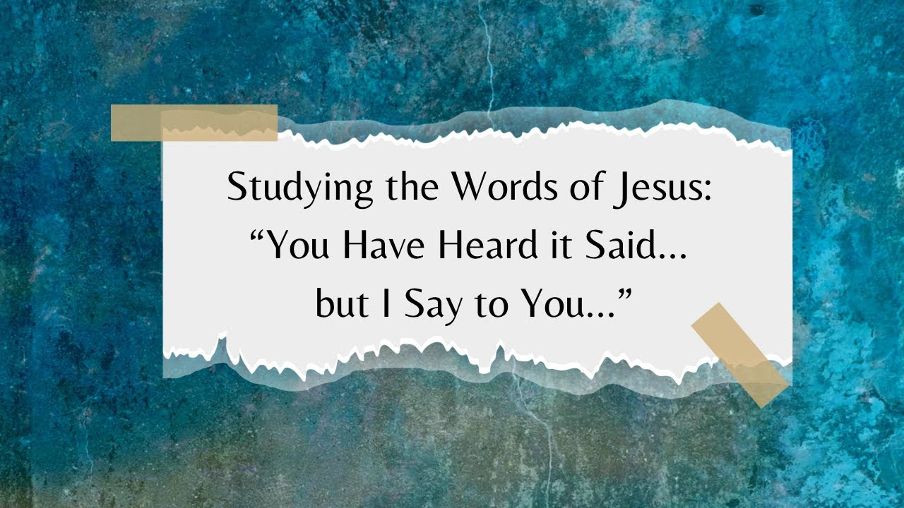

Yorkshire United Methodist Church
125 Edgewood Road
York, PA 17403
717-7554952
www.yorkshirechurch.org

Our Mission
Follow Jesus. Live His Word. Love Others.

