the Sixteenth Sunday after Pentecost
Combined Service
September 13, 2026 – 10:00 AM
PREPARATION for WORSHIP
The Prelude “Amazing Grace”

Welcome to Worship
(We bid special welcome to our guests today and encourage you to complete
a visitor’s card as found in the pew. We would be glad to contact you if you
wish. Thank you for being with us as we worship God.)

WORSHIP through PRAISE
The Call to Worship “Shine, Jesus, Shine” (See Screen)

The Bidding Prayer

*The Song of Praise

Our Call to Prayer and Praise
Leader: As we come to worship, let us leave at the door our self-centered thoughts
People: And open our eyes to see our neighbor in worship.
Leader: As we come to worship, let us leave at the door our feelings of exclusiveness
People: And open our minds to the possibilities of inclusion.
Leader: As we come to worship, let us leave outside our notion of generosity
People: And open our hearts to the possibility of giving beyond our typical gift
All: Yes, let us open our eyes, our minds, and our hearts to what can be instead of what is. For
all of our gifts and for all possibilities, let us lift our voices in praise!

A Prayer for Greater Discipleship (Unison)
Gathering God, you have promised that if we draw near to you, you will draw near to us. In this
time, prepare our hearts and minds that we might receive your wisdom and understanding. Relieve
our bodies and souls from all the desires and cravings shaped by this world, that we might be filled
with your peace. Pour out your Spirit upon us, that our worship might be joyful and authentic,
bearing good fruit in our lives with our neighbors. In the name of Jesus Christ, risen Savior, we
pray. Amen.

A Time of Silent Prayer and Meditation

Our Prayer of Confession (Unison)
Forgiven, holy, set apart. Righteous, clean, blameless. These are not words we would use to
describe ourselves. We know we are sinners, broken by the fall. And yet, because of Jesus, you do
not see us this way any longer. You have changed us and renamed us. God, we bring our sins before
you today and confess that we have failed. We have failed in forgiveness, patience, basic kindness,
self-discipline and spiritual devotion. We are needy and sorrowful. Forgive us, we pray. In the name
of Jesus, forgive us. Amen.
Words of Comfort, Assurance, and Instruction
Leader: In the name of Jesus, receive your forgiveness and know that we are not defined by our past
any longer… We are defined by our future, in Christ.

The Song of Prayer

The Prayers of Our People, Pastoral Prayer, and Lord’s Prayer

Morning Anthem “We Are The Church”

WORSHIP with GIFTS of TITHES and OFFERINGS
The Call
The Prayer of Dedication
The Offertory “Oh, How He Loves You and Me”

WORSHIP through PROCLAMATION OF THE WORD
The Scripture Lesson Matthew 5:17-20

The Hymn of Preparation “Love Divine, All Loves Excelling”
No. 384
The Sermon Being Sermon on the Mount Christians
Part 12: The Law and the Gospel of Christ

*The Hymn of Dedication “The Gift of Love” No. 408

*The Benediction

*The Postlude “Christians, Let Us Go and Serve Him”

Jackie Linsey, Organist
Jazze Palmer, Musician

The Altar Flowers are presented by
Steve & Lynn Spangler
in honor of our Grandson,
Bennett’s 4th birthday
on September 12th!

TODAY is our Community Fest!
Please join us after the service from 11:30-2pm for fun, food and fellowship!

Women’s Fellowship Dinner
Join us on Monday, September 14th @6pm in the Fellowship Hall.
Please bring a covered dish to share.
Last name starting with a letter A-G: Main Dish; H-P: Side Dish; Q-Z: Dessert.
See Julie Mann with any questions!

Greeters Needed
We are in need new Greeters for the 11:15 service!
If you can open a door, pass out bulletins and smile at your friends, you are qualified.
Potential attendees need to see that same smiling face to feel welcome at our church.
Please contact John Remsen for more information.

Zippy Beef Casseroles
A sign-up sheet for October casseroles is in the narthex.
Casseroles are due by September 30th.
We are looking for some new volunteers to help fulfill this need!

EVENTS THIS WEEK:
Wednesday
“Men at the Sixes” @6am - Fellowship Hall
Bible Study @6pm – Youth Room
The Well @7:15pm – Room 206

Thursday
Prayer Breakfast @8am- Two Brothers Restaurant
Choir Rehearsal – 6pm

UPCOMING EVENTS:
Preschool Sub Fundraiser
Starts September 20th – October 13th

Trunk or Treat
Oct 24th – 10-12pm

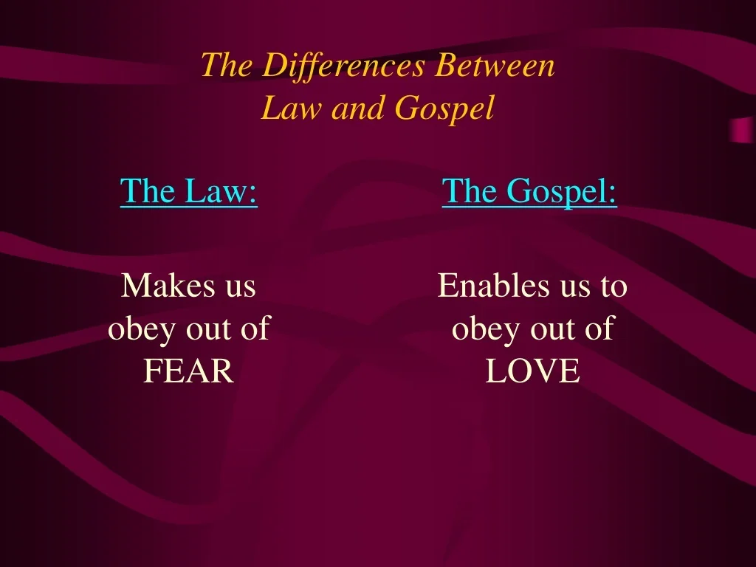

Yorkshire United Methodist Church
125 Edgewood Road
York, PA 17403
717-7554952
www.yorkshirechurch.org

Our Mission
Follow Jesus. Live His Word. Love Others.

