The Fourteenth Sunday after Pentecost
contemporary service
august 30, 2026 – 9:00am
_______________________________________

Call to Worship Video

Welcome and Announcements

The Bidding Prayer

*Opening Song

Our Prayers

*A Song of Praise and Preparation

Our Worship with Gifts of Tithes and Offerings
The Call
The Prayer of Dedication
Special Music

The Scripture Lesson
Matthew 5:13-16

The Sermon
Being Sermon on the Mount Christians
Part 10: Salt and Light

*Closing Song

*Benediction

*Please stand as you are able

Jazze Palmer, Musician

the Fourteenth sunday after Pentecost
traditional service
August 30, 2026 - 11:15 AM
PREPARATION for WORSHIP
The Prelude

Welcome to Worship
(We bid special welcome to our guests today and encourage you to complete
a visitor’s card as found in the pew. We would be glad to contact you if you
wish. Thank you for being with us as we worship God.)

WORSHIP through PRAISE
The Call to Worship “He Is Exalted” (See Screen)
Twila Paris
The Bidding Prayer

*The Hymn of Praise “Amazing Grace” No. 378
(We will sing vss. 1-4, 6. Omitting vs. 5)
*The Apostle’s Creed No. 881

The Call to Prayer and Praise (Responsively (from Psalm 31)
Leader: Praise the Lord, who has shown us the wonders of
his unfailing love; and who, for the sake of his
name, leads us and guides us.
People: In you, O Lord, we put our trust. You are our
God, and our lives are in your hands.
Leader: Lord, let the light of your face shine on us as we
celebrate together in your presence.

A Prayer for Greater Discipleship (Unison)
God of truth, we come longing for the peace that only
you can provide. We seem so often to be tossed to and fro,
blown about by every wind except that of your own Holy
Spirit. Be pleased to dwell here this day, to receive our
worship and our praise. Linger long, and speak the truth to
us in love that we may come to the unity of faith and to
the knowledge of the full stature of Christ, in whose name
we pray. Amen.

A Time of Silent Prayer and Meditation

Our Prayer of Confession (Responsively)
Leader: O Lord our God, you are wise; You know our thoughts
before we reveal them to you.
People: O Lord our God, you are compassionate; You know
our joys and fears before we name them to you.
Leader: O Lord our God, you are just; You offer us mercy while
we cringe at the expectation of judgment and
punishment.
People: O Lord our God, you welcome every one of us; In
spite of our weaknesses, our failures, our doubts, you
invite each one of us into your presence.
All: We praise you and humble ourselves before you, O
Lord our God. Amen.

Words of Comfort, Assurance, and Instruction
Leader: Who do we say Jesus is? He is the judge of all -- but
the one who was judged. He knew no sin, yet he took
on the powers of sin for our sake. Let us thank God that
through his loving sacrifice we are redeemed and our
sins are forgiven. Amen.

The Hymn of Prayer “I Need Thee Every Hour” No. 397

The Prayers of Our People, Pastoral Prayer, and Lord’s Prayer

Special Music

WORSHIP with GIFTS of TITHES and OFFERINGS
The Call
The Prayer of Dedication
The Offertory

WORSHIP through PROCLAMATION OF THE WORD
The Scripture Lesson Matthew 5:13-16

The Hymn of Preparation “His Eye Is on the Sparrow”
(See Screen)
The Sermon Being Sermon on the Mount Christians
Part 10: Salt and Light

*The Hymn of Dedication “Let There Be Peace on Earth”
No. 431
*The Benediction and Postlude
Beth Gross, Organist

The Altar Flowers are presented
anonymously to the dedicated
volunteers who invest their time,
love, and wisdom to shape the
faith of all the children in
Sunday School and CLIMB.
Thank you!

HOLY COMMUNION: Next week, Labor Day Sunday, September 6th we will celebrate Holy Communion. Please plan to attend.

SUNDAY SCHOOL NEWS
Each child in Sunday School is a Creation of God.
They are making their own “Masterpieces” each week that represent them. The Masterpieces will be displayed
in the upstairs hallway and will change each week.
The children and teachers invite everyone to see their creations!

GREETERS: We need new Greeters for the 11:15 service! Through attrition and medical issues, we are down to three Greeters for that service. If you can open a door, pass out bulletins and smile at your friends, you are qualified. Potential attendees need to see that same smiling face to feel welcome at our church. Greeters are essential to bring new attendees into Yorkshire. Please contact John Remsen for more information.

EVENTS THIS WEEK

Wednesday, Sept 2nd
“Men at the Sixes” @6am - Fellowship Hall

Thursday, Sept. 3rd
Prayer Breakfast @8am- Two Brothers Restaurant
Choir Rehearsal – 6pm



UPCOMING EVENTS

Combined Church Service/Community Fest
Sept 13th Combined Service @10am followed by the
Community Fest 11:30-2pm

Church Staff
Roger Mentzer, Pastor
Stacey Roache, Administrative Assistant
Matthew Hochmiller, Choir Director
Jackie Linsey, Organist
Beth Gross, Organist
Jazze Palmer, Contemporary Musician
Chris Bare, Custodian
Julie Mann, Preschool Director

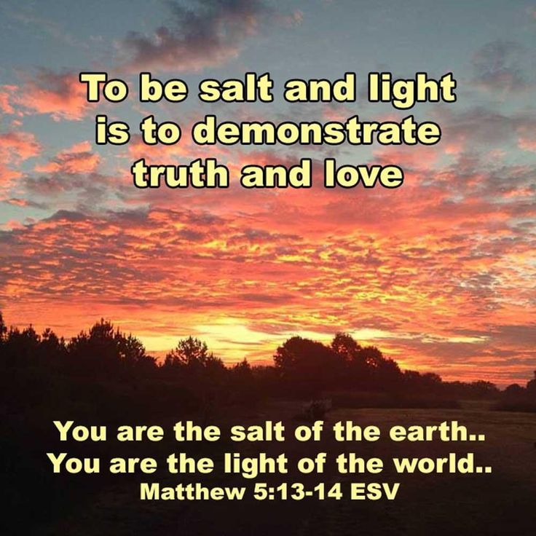

Yorkshire United Methodist Church
125 Edgewood Road
York, PA 17403
717-7554952
www.yorkshirechurch.org

Our Mission
Follow Jesus. Live His Word. Love Others.

