The Thirteenth Sunday after Pentecost
contemporary service
august 23, 2026 – 9:00am
_______________________________________

Call to Worship Video

Welcome and Announcements

The Bidding Prayer

*Opening Song

Our Prayers

*A Song of Praise and Preparation

Our Worship with Gifts of Tithes and Offerings
The Call
The Prayer of Dedication
Special Music

The Scripture Lesson
Matthew 5:10-12

The Sermon
Being Sermon on the Mount Christians
Part 9: The Bliss of the Sufferer for Christ

*Closing Song

*Benediction

*Please stand as you are able

Jazze Palmer, Musician

the Thirteenth sunday after pentecost
traditional service
August 23, 2026 - 11:15 AM
PREPARATION for WORSHIP
The Prelude Andante Tranquillo in A

Welcome to Worship
(We bid special welcome to our guests today and encourage you to complete
a visitor’s card as found in the pew. We would be glad to contact you if you
wish. Thank you for being with us as we worship God.)

WORSHIP through PRAISE
The Call to Worship “He Is Exalted” (See Screen)
Twila Paris
The Bidding Prayer

*The Hymn of Praise “Immortal, Invisible, God Only Wise”
No. 103
Our Call to Prayer and Praise
Leader: As Jesus called disciples so long ago -- Peter ...
Andrew ... Mary ... James ... Martha ... Mary
Magdalene ... John ...
People: Let us listen for our own names, written on God's
heart and called in the voice of the Spirit.
Leader: They were fishermen, tax collectors, brothers and
sisters. God transformed them into the beloved
community.
People: We are the same as a gathering of professions,
fathers and mothers, brothers and sisters.
All: May God transform us into the beloved community.
May our prayer and praise give glory to God!

A Prayer for Greater Discipleship (Unison)
Use me, my Savior, for whatever purpose and in whatever way
you may require. Here is my poor heart, an empty vessel: Fill it
with your grace. Here is my sinful and troubled soul: Quicken it
and refresh it with your love. Take my heart for your home; my
mouth to spread abroad the glory of your name; my love and all
my powers for the advancement of your believing people; and
never allow the steadfastness and confidence of my faith to fail.
Amen.
A Time of Silent Prayer and Meditation

Our Prayer of Confession (Unison)
Father, you are so patient with us. You have told us that if we
have the faith of a mustard seed, we can move mountains and,
yet, even that seems impossible for our doubting hearts. We
have seen your miracles, we have experienced your work in our
lives, and we still question you and hesitate to believe you are
always good. Let us not so quickly forget the celebration we had
last week and the truth of the resurrection. Give us faith to
believe you, Father. Amen.

Words of Comfort, Assurance, and Instruction
Leader: Hear the good news! God’s Spirit has been poured out
upon all flesh, and we have been made new. We are no
longer scattered or divided, but gathered together to
build up the kingdom on this earth. Thanks be to God!

The Hymn of Prayer “Open My Eyes, That I May See” No. 454

The Prayers of Our People, Pastoral Prayer, and Lord’s Prayer

Special Music "Let There Be Praise"
"Your First Day in Heaven"
By: Bud Bish, Bob Martin, Randy Smith

WORSHIP with GIFTS of TITHES and OFFERINGS
The Call
The Prayer of Dedication
The Offertory Simple Gifts

WORSHIP through PROCLAMATION OF THE WORD
The Scripture Lesson Matthew 5:10-12

The Hymn of Preparation “Must Jesus Bear the Cross Alone”
No. 424
The Sermon Being Sermon on the Mount Christians
Part 9: The Bliss of the Sufferer for Christ

*The Hymn of Dedication “Let There Be Peace on Earth”
No. 431
*The Postlude Jesus, United by Thy Love
Jackie Linsey, Organist


ALTAR FLOWERS
The Altar Flowers are presented by Wayne Howell in loving memory of the late Susan V. Howell, who would have been celebrating her 58th wedding anniversary to husband Wayne
on August 25th.

VOLUNTEERS NEEDED! We need new Greeters for the 11:15am service! Through attrition and medical issues, we are down to three Greeters for that service. If you can open a door, pass out bulletins and smile at your friends, you are qualified. Potential attendees need to see that same smiling face to feel welcome at our church. Greeters are essential to bring new attendees into Yorkshire. Please contact John Remsen for more information.

WEDNESDAY EVENING BIBLE STUDY Just a reminder that our Wednesday evening Bible study will reconvene at 6pm on Wednesday Sept 9th in the Youth Room. We will be studying Proverbs once again and welcome everyone to join us for an hour of friendly study, conversation and good gospel. We learn from scripture through shared experiences and life lessons. There are 10 of us now and we would love to have you join us. Please give it some thought and see John Remsen if you have questions!
COMING SOON! The Well – Where Faith and Wellness Meet will begin on Wednesdays starting Sept 9th @7:15pm. Brochures for the new group – The Well are in the lobby. Please see Pam Terry for more information!
SUNDAY SCHOOL NEWS Each child in Sunday School is a Creation of God. They are making their own “Masterpieces” each week that represent them. The Masterpieces will be displayed in the upstairs hallway and will change each week. The children and teachers invite everyone to see their creations!

EVENTS THIS WEEK

Wednesday, Aug 26th
“Men at the Sixes” @6am - Fellowship Hall

Thursday, Aug 27th
Prayer Breakfast @8am- Two Brothers Restaurant

Saturday, Aug 29th
Extra Choir Rehearsal @10am



UPCOMING EVENTS

Combined Church Service/Community Fest
Sept 13th Combined Service @10am followed by the
Community Fest 11:30-2pm

Church Staff
Roger Mentzer, Pastor
Stacey Roache, Administrative Assistant
Matthew Hochmiller, Choir Director
Jackie Linsey, Organist
Beth Gross, Organist
Jazze Palmer, Contemporary Musician
Chris Bare, Custodian
Julie Mann, Preschool Director

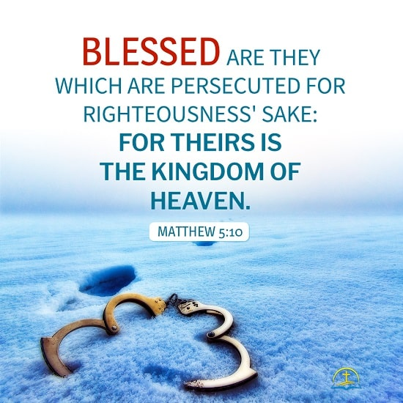

Yorkshire United Methodist Church
125 Edgewood Road
York, PA 17402
717-755-4952
www.yorkshirechurch.org

Our Mission
Follow Jesus. Live His Word. Love Others

