The Ninth Sunday after Pentecost
contemporary service
july 26, 2026 – 9:00am
____________________________________

Call to Worship Video

Welcome and Announcements

The Bidding Prayer

*Opening Song

Our Prayers

*A Song of Praise and Preparation

Our Worship with Gifts of Tithes and Offerings
The Call
The Prayer of Dedication
Special Music

The Scripture Lesson
Matthew 5:6

The Sermon
Being Sermon on the Mount Christians
Part 5: The Bliss of the Starving Spirit

*Closing Song

*Benediction

*Please stand as you are able

Jazze Palmer, Musician

the ninth sunday after pentecost
traditional service
july 26, 2026 – 11:15am

PREPARATION for WORSHIP
The Prelude “Canon in D”

Welcome to Worship
(We bid special welcome to our guests today and encourage you to complete
a visitor’s card as found in the pew. We would be glad to contact you if you
wish. Thank you for being with us as we worship God.)

WORSHIP through PRAISE
The Call to Worship “Lord, Listen to Your Children Praying”
(See Screen) Medema
The Bidding Prayer

*The Hymn of Praise “Praise to the Lord, the Almighty”
No. 139
OUR CALL to PRAYER and PRAISE
Leader: "All we like sheep have gone astray; we have all turned
to our own way; and the Lord has laid on him the
iniquity of us all."
People: You revealed your law to Moses, O God, but your
people set up a golden calf.
Leader: You challenged them, through your great prophets, to
seek justice for the poor; but your people preferred
false prophets who set their consciences at ease.
People: At last, O God, you sent your own Son to woo them
back; but your people plugged up their ears and led
him to the cross to be crucified.
Leader: We are your people, O God, all of us: Guilty, judged,
seeking forgiveness.
People: Accept our plea for mercy,
All: For we offer it in the name of your Son, our crucified,
merciful Lord. Amen.

A Time of Silent Prayer and Meditation


Our Prayer for Greater Discipleship
Leader: O Holy One, we thank you that we stand in a long line
of believers who have been faithful through the ages.
We pray that you would bless us in our time as we seek
to be as faithful as our forebears. Fill us with hope.
All: Give to us a faith like the grain of mustard seed, which
had small beginnings, but which yielded large results.
Faith to move the mountains of difficulty which come
to each of us. Faith which has a vision of a new world
where peace and love characterize the transactions of
people… where war is no more. Faith such as
Abraham’s to move forward trusting in your guiding
providence. Faith which sees the welfare of humankind as our business because it is the focus of your enduring
love for your people. Faith which sees beyond the
years to an eternal city.
Leader: God, give us faith to walk with you through the ebb
and flow, the loving joys and the harsh sorrows of life
and that we may achieve victory in Jesus. Amen.

The Hymn of Prayer “Victory in Jesus” No. 370

The Prayers of Our People, Pastoral Prayer, and Lord’s Prayer

Special Music “Abide"
Sung by Norey Lucash and Ben Bailey

WORSHIP with GIFTS of TITHES and OFFERINGS
The Call
The Prayer of Dedication
The Offertory “My Faith Looks Up to Thee”

WORSHIP through PROCLAMATION OF THE WORD
The Scripture Lesson Matthew 5:6

The Hymn of Preparation “Love Divine, All Loves Excelling”
No. 384
The Sermon Being Sermon on the Mount Christians
Part 5: The Bliss of the Starving Spirit

*The Hymn of Dedication “Let There Be Peace on Earth”
No. 431
*The Benediction and Postlude Lob Den Herren
Beth Gross, Organist


The Altar Flowers are presented by
The Mingora Family
In Memory of Tony Mingora,
the 10th anniversary of his death, July 29, 2016
“B+ for Life”
With Love, The Mingora Family

GIVING HEART TREE
All hearts have been claimed!
Thank you for your thoughtfulness and generosity!!

CORNERS OF YOUR FIELD PARTNERSHIP
We have partnered with LifePath and
have placed a donation bin in the church parking lot.
LifePath accepts shoes & clothing.
Start cleaning out those closets!
Yorkshire will receive credit for each donation given.

OUR PRESCHOOL IS GROWING!
With growing comes the need for
additional teachers and volunteers.
We are looking for:
Volunteer - 2-year-old class helper
Every other Tuesday from 9-11:30
Being with 2-year-olds as they discover the world
will warm your heart every time you are with them.
Contact the church if you or someone you know is interested.

THIS WEEK
Wednesday
“Men at the Sixes” @6am - Fellowship Hall

Thursday
Prayer Breakfast @8am- Two Brothers Restaurant

Administrative Assistant
Our Administrative Assistant is on vacation through Aug 1st.
Please reach out to Pastor Roger
if you need anything during this time

UPCOMING EVENTS

Youth Group
Aug 2nd – Pool Party @5pm - @The Focht’s

National Night Out
Aug 4th 5-7pm @ Springettsbury Park

Combined Church Service/Community Fest
Sept 13th Combined Service @10am followed by the
Community Fest 11:30-2pm
Church Staff
Roger Mentzer, Pastor
Stacey Roache, Administrative Assistant
Matthew Hochmiller, Choir Director
Jackie Linsey, Organist
Beth Gross, Organist
Jazze Palmer, Contemporary Musician
Chris Bare, Custodian
Julie Mann, Preschool Director

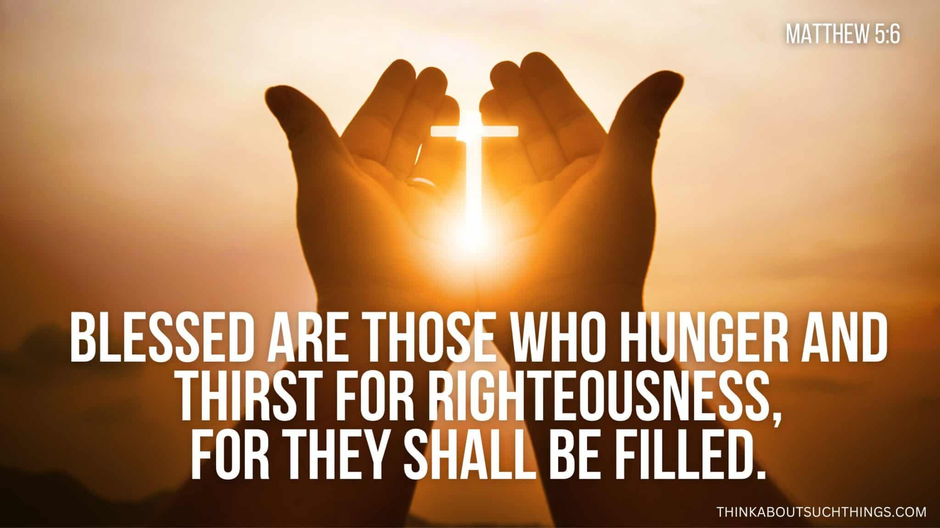

Yorkshire United Methodist Church
125 Edgewood Road
York, PA 17402
717-755-4952
www.yorkshirechurch.org

“Biblically Speaking”

