The Fifth Sunday after Pentecost
Contemporary service
june 28, 2026 – 9:00am
_____________________________________

Call to Worship Video

Welcome and Announcements

The Bidding Prayer

*Opening Song
“What an Awesome God”

Our Prayers

*A Song of Praise and Preparation
“Goodness of God”

Our Worship with Gifts of Tithes and Offerings
The Call
The Prayer of Dedication
Special Music
“Reckless Love”

The Scripture Lesson
Matthew 7:24-29

The Sermon
Being Sermon on the Mount Christians
Part 1: Why Think Like This

*Closing Song
“I Know a Name”

*Benediction

*Please stand as you are able

Jazze Palmer, Musician

the fourth sunday after pentecost
Yorkshire United Methodist Church
June 28, 2026 - 11:15 AM

PREPARATION for WORSHIP
The Prelude

Welcome to Worship
(We bid special welcome to our guests today and encourage you to complete
a visitor’s card as found in the pew. We would be glad to contact you if you
wish. Thank you for being with us today as we worship God.)

WORSHIP through PRAISE
The Call to Worship “As a Fire Is Meant for Burning” (Screen)

The Bidding Prayer

*The Hymn of Praise “Guide Me, O Thou Great Jehovah” No. 127

The Call to Prayer and Praise
Leader: Listen, friends! God is speaking! God's voice whispers
stillness and thunders across the skies. It breaks out
from the heavens. All creation proclaims the glory of
the Lord.
People: God also speaks through the Word. In Jesus, that
Word took on flesh to make God known to us. The
Word is truth and life, and proclaims the promises and
purposes of God.
Leader: Listen, friends! God is speaking! Let us be wise to hear
and do as his word speaks. Let us pray:
All: O God, as our creator you are one of us; as your Son
Jesus, you are one of us; as the Holy Spirit, you are
within us: Give me a pure heart, that I may see thee.
Give me a humble heart that I may hear thee. Give
me a heart of love that I may serve thee. Give me
a heart of faith that I may abide in thee. Amen.

A Time of Silent Prayer and Meditation

Our Prayer for Greater Discipleship
Lord, so many folks misunderstand, thinking Christianity is a
way for perfect people. Too many imagine that once one joins,
everything is smooth or at least appears to be. It isn’t true.
Working to become Christ-like is an extra burden. Jesus did not
favor the good folks. He ate with sinners, healed the sick, spoke
to the confused, welcomed lepers and cared for unpopular
bureaucrats. We don’t belong to Jesus because we are good. We
come to him, because we sin. And Lord, we know in his
redeeming love and your grace, we grow and grow into his
likeness. May it be so today. Amen.

The Hymn of Prayer “Lord, I Want to Be a Christian” No. 402

The Prayers of Our People and Pastoral Prayer

Special Music “Eternal Father, Strong To Save” "
Ryan Chen, Piano

WORSHIP with GIFTS of TITHES and OFFERINGS
The Call
The Prayer of Dedication
The Offertory

WORSHIP through PROCLAMATION OF THE WORD
The Scripture Lesson Matthew 7:24-29

The Hymn of Preparation “Thy Word Is a Lamp unto My Feet”
No. 601
The Sermon Being Sermon on the Mount Christians
Part 1: Why Think Like This

*The Hymn of Dedication “Lead On, O King Eternal” No. 580

*The Benediction and Postlude

Beth Gross, Organist

The Altar Flowers are presented to
The Glory of God by Yorkshire Church

Our guest musician today is Ryan Chen,
a recent graduate of Central York High School and
a "graduate" of Matt Hochmiller's piano studio.
He will be attending Penn State University this fall,
majoring in data science.
Thanks to Ryan for sharing his talent!

YOUTH GROUP– TODAY!
The Youth Group will be meeting for Mini Golf and Ice Cream
at 5:30pm at Jim Mack’s in Hellam. Bring a friend!

GIVING HEART TREE:
The Giving Heart Tree has been placed in the lobby.
Please consider supporting our children’s ministries
by selecting a heart from the tree.
Place the purchased items in the church lobby by Aug 2nd.
Amazon items can be delivered directly to the church.

OUR PRESCHOOL IS GROWING!
With growing comes the need for additional teachers.
We are looking for: 4’s – Teacher – M, W, F 8:30-1pm
Must have teaching experience.
Contact the church if you or someone you know is interested.

YOUTH DIRECTOR NEEDED:
We are seeking someone to serve as our Director of Youth Ministries.
This is a part-time paid position.
Please reach out to Pastor Roger
if you or someone you know is interested.
THIS WEEK:
Today
Youth Group Mini Golf & Ice Cream @530pm
Jim Macks in Hellam

Monday
Women’s Ice Cream Social @7pm
Mack’s in Hellam

Wednesday
“Men at the Sixes” @6am - Fellowship Hall

Thursday

Prayer Breakfast @8am- Two Brothers Restaurant

UPCOMING EVENTS
Youth Group
July 12th @ 5:30pm – Water Balloon Capture the Flag
Aug – Pool Party - date to be determined

Community Fest Planning Meeting
July 15 @6:30pm – Room 202
Anyone interested in helping with planning the Sept 13th event is welcome to attend!

National Night Out
Aug 4th 5-7pm @ Springettsbury Park

Combined Church Service/Community Fest
Sept 12th Combined Service @10am followed by the
Community Fest 11:30-2pm

Church Staff
Roger Mentzer, Pastor
Stacey Roache, Administrative Assistant
Matthew Hochmiller, Choir Director
Jackie Linsey, Organist
Beth Gross, Organist
Jazze Palmer, Contemporary Musician
Chris Bare, Custodian
Julie Mann, Preschool Director

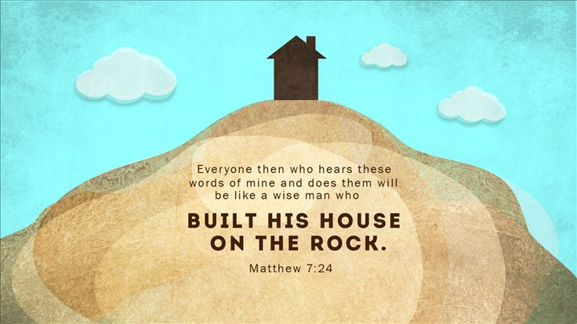

Yorkshire United Methodist Church
125 Edgewood Road
York, PA 17402
717-755-4952
www.yorkshirechurch.org

“Biblically Speaking”

