The Fourth Sunday after Pentecost – Father’s Day contemporary service
june 21, 2026 – 9:00am
___________________________________________

Call to Worship Video

Welcome and Announcements

The Bidding Prayer

*Opening Song

Our Prayers

*A Song of Praise and Preparation

Our Worship with Gifts of Tithes and Offerings
The Call
The Prayer of Dedication
Special Music

The Scripture Lesson
Matthew 13:1-9; 18-23

The Sermon
Six Ways in Which We Can Pray

*Closing Song

*Benediction

*Please stand as you are able

Jazze Palmer, Musician

The fourth sunday after pentecost – father’s day
traditional service
june 21, 2026 – 11:15am

PREPARATION for WORSHIP

The Prelude Faith of Our Fathers

Welcome to Worship
(We bid special welcome to our guests today and encourage you to complete
a visitor’s card as found in the pew. We would be glad to contact you if you
wish. Thank you for being with us today as we worship God.)

WORSHIP through PRAISE
The Call to Worship “As a Fire Is Meant for Burning” (Screen)

The Bidding Prayer

*The Hymn of Praise “This Is My Father’s World” No. 144

The Call to Prayer and Praise
Leader: Welcome home. Yes, God bids us to come, to find
rest for our weariness, and find peace deeper than
our worry.
People: Welcome home, all you lost, wandering or stuck in
despair. Welcome indeed to God’s arms, as wide as
a father’s care, as warm as a mother’s love.
Leader: Let us pray together:

Our Prayer of Invocation
Almighty God, you have set us as individual families. May our
families be strengthened by your Spirit. Keep us close together
so that no challenge can unravel the bindings of love that unite
us. On this Father’s Day, we pray that you will turn our hearts in
tenderness toward one another and towards you, our Heavenly
Father. Receive our gratitude as we lift silent prayers of thanks
for all those through whom you have blessed our pilgrimage,
whose lives have empowered us and whose influence is a
healing grace.

A Time of Silent Prayer and Meditation



Our Prayer of Devotion
On this day when we remember what it means to have a
father or be a father, we recognize the importance of fathers in
our communities. We pledge as a congregation to love and
nurture the fathers among us so that they will manifest the love
of God in all that they do. We devote ourselves to you, our
loving God, you who are our father and our mother. We thank
you that you have shown us how important it is to follow your
example as we grow in faith. Teach us to be obedient to your
will, respecting you as children ought. Thank you for your mercy
despite our disobedience. Strengthen us to stand up against the
challenges of this world, honoring your name and trusting your
grace. In the Name of your Son, we pray. Amen.

A Song of Prayer and Praise
“Prayer Is the Soul’s Sincere Desire” No. 492

The Prayers of Our People and Pastoral Prayer

Special Music “Father, Long Before Creation”

WORSHIP with GIFTS of TITHES and OFFERINGS
The Call
The Prayer of Dedication
The Offertory Children of the Heavenly Father

WORSHIP through PROCLAMATION OF THE WORD
The Scripture Lesson Matthew 13:1-9; 18-23

The Hymn of Preparation “All Creatures of Our God and King”
(verses 1, 4, and 7 only) No. 62

The Sermon Six Ways in Which We Can Pray

*The Hymn of Dedication “Every Time I Feel the Spirit” No.404

*The Benediction and Postlude Trumpet Tune and March

Jackie Linsey, Organist

The Altar flowers are presented to
The Glory of God by Yorkshire Church

UPCOMING YOUTH GROUP EVENTS:
Our Youth Group will be meeting once/month over the summer as follows:
June 28th @5:30pm – Mini Golf & Mack’s Ice Cream
July 12th @5:30pm – Water Balloon Capture the Flag
Aug – date to be determined – Pool Party

OUR PRESCHOOL IS GROWING! With growing comes
the need for additional teachers. We are looking for:
4’s – Teacher – M, W, F 8:30-1pm – Must have teaching experience. Contact the church if you or someone you know is interested in this position.

YOUTH DIRECTOR: We are seeking someone to serve as our Director of Youth Ministries. This is a part-time paid position. Please reach out to Pastor Roger if you or someone you know is interested.

LOST & FOUND: Please check the Lost & Found basket in the hallway next to the Narthex for any lost items. We have had an increase in items found that may be yours!

OUR DAILY BREAD/ZIPPY BEEF CASSEROLES: There is a signup sheet for July in the narthex. Casseroles are due by June 30th.


Wishing all the men of Yorkshire Church a
Happy Father’s Day!

Thank you for all you do!

THIS WEEK:

Wednesday
“Men at the Sixes” @6am - Fellowship Hall

Thursday
Prayer Breakfast @8am- Two Brothers Restaurant



UPCOMING EVENTS:

June 28th – Youth Group Mini Golf & Ice Cream – 5:30pm
Mack’s Ice Cream, Hellam – Invite a friend!

June 29th – Women’s Ice Cream Social - 7pm
Mack’s Ice Cream, Hellam

July 12th – Youth Group Monthly Event – 5:30pm
Yorkshire Church

Aug 4th – National Night Out – 5-8pm
Springettsbury Park – more info to come@

Church Staff
Roger Mentzer, Pastor
Stacey Roache, Administrative Assistant
Matthew Hochmiller, Choir Director
Jackie Linsey, Organist
Beth Gross, Organist
Jazze Palmer, Contemporary Musician
Chris Bare, Custodian
Julie Mann, Preschool Director

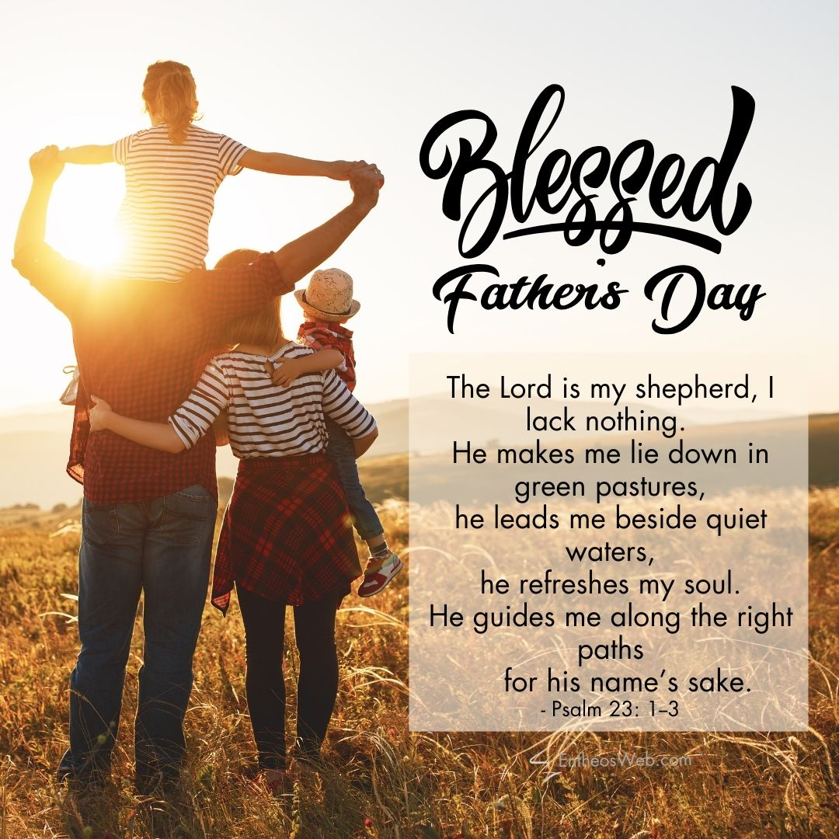

Yorkshire United Methodist Church
125 Edgewood Road
York, Pa 17402
717-755-4952
www.yorkshirechurch.org

“Biblically Speaking”

