The Fifth Sunday of Easter
contemporary service
May 3, 2026 - 9:00 AM

Call to Worship Video

Welcome and Announcements

The Bidding Prayer

*Opening Song

Our Prayers

*A Song of Praise and Preparation

Our Worship with Gifts of Tithes and Offerings
The Call
The Prayer of Dedication
Special Music

The Scripture Lesson
Romans 12:9-21

The Communion Meditation
After Communion, Then What?

A Time with Our Children

The Sacrament of Holy Communion

*Closing Song

*Benediction

Jazze Palmer, Musician

*Please stand as you are able

the fifth sunday of easter
traditional service
May 3, 2026 - 11:15 AM
PREPARATION for WORSHIP
The Prelude “God, The Almighty”

The Choral Introit

Welcome to Worship
(We bid special welcome to our guests today and encourage you to complete
a visitor’s card as found in the pew. We would be glad to contact you if you
wish. Thank you for being with us today as we worship God.)

WORSHIP through PRAISE
The Call to Worship “Lamb of God” Twila Paris (See Screen)

The Bidding Prayer

*The Hymn of Praise “God, Whose Love is Reigning O’er Us”
No. 100
The Call to Prayer and Praise
Leader: People of God, open the doors of your hearts today.
People: We open our minds and souls to the presence of the
living Lord among us.
Leader: Friends and neighbors in Christ, today the Lord may
ask you to surrender that which you hold dear.
People: We are ready for whatever Christ asks of us.
Leader: Faithful pilgrims, may the Lord bless you with the
strength to give up whatever stands in the way of the
love of Christ. Sing, be glad, and celebrate the joy of
this day.
The Prayer of Invocation
Send your Spirit, faithful God, and instill in us the mind of
Christ. Bind us together in joy and affection, that we may look
not only to our own welfare, but also to the welfare of others.
For the sake of Jesus we pray. Amen.
A Time of Silent Prayer and Meditation

Our Prayer of Confession
Look deep, loving God, and see us as we really are –
yearning to be close to you but fearful of what you may ask. Our
desire to be faithful is woven with our hesitancy to go the extra
mile; our wanting to be loving is diluted by our resistance to
caring in particular situations. Loving God, we are a tangled vine.
Prune us and train us to grow in your holy way. Amen.
Words of Comfort, Assurance, and Instruction
Leader: Before the God of eternity, lips are silenced in awe
and wonder. Mere words fail to praise the fullness of
your Word for us spoken in Jesus Christ.
People: We pray that our lives would reflect God’s love and
so return to God all praise and glory by all we say
and do. Amen.

A Song of Prayer and Praise
“The King of Love My Shepherd Is” No. 138

The Prayers of Our People and Pastoral Prayer

The Morning Anthem

WORSHIP with GIFTS of TITHES and OFFERINGS
The Call
The Prayer of Dedication
The Offertory “Break Thou The Bread Of Life”

WORSHIP through PROCLAMATION OF THE WORD
The Scripture Lesson Romans 12:9-21

The Hymn of Preparation “O Breath of Life” No. 543

The Communion Meditation After Communion: Then What?

The Sacrament of Holy Communion

*The Hymn of Dedication “Because He Lives” No. 364

*The Benediction and Postlude “Freely, Freely, Give”
Jackie Linsey, Organist



The Altar Flowers are presented by Stephen Coates
in honor of Susan Coates
on our 48th wedding anniversary since 5/6/78,
to be celebrated on that very memorable date
and throughout the month of May

PENTECOST SUNDAY FLOWERS: Order forms for Red Geraniums are enclosed for Pentecost Sunday. The flowers are 4.5” pots for $5.50 each. Orders are due by May 11th.

OUR PRESCHOOL IS GROWING! With growing comes the need for additional teachers. We are looking for:
4’s – Teacher – M, W, F 8:30-1pm - Must have teaching experience. Contact the church if you or someone you know is interested in this position.

YOUTH DIRECTOR: We are seeking someone to serve as our Director of Youth Ministries. This is a part-time paid position. Please reach out to Pastor Roger if you or someone you know is interested.

VOLUNTEERS NEEDED: We are in need of volunteers to help out with the Sound Board at the 11:15 am service. Volunteers would only be scheduled once or twice every three months. This is a very important ministry that enhances the quality of our church services. Please see Frank Herron at church or contact him at 717-887-3792 for more information.

THIS WEEK:

Sunday
Healthy Kids Running Series @4-5pm
Youth Group @530pm

Monday
Women’s Bible Study @7pm-Fellowship Hall

Wednesday
“Men at the Sixes” @6am - Fellowship Hall
Bible Study @6pm in the Youth Room

Thursday
Prayer Breakfast @8am- Two Brothers Restaurant
Choir @6:15pm in the Music Room

UPCOMING EVENTS:

May 3rd, May 10th and May 17th
Healthy Kids Running Series – 4-5pm

May 17th – Preschool Sunday @9am

Church Staff
Roger Mentzer, Pastor
Stacey Roache, Administrative Assistant
Matthew Hochmiller, Choir Director
Jackie Linsey, Organist
Beth Gross, Organist
Jazze Palmer, Contemporary Musician
Chris Bare, Custodian
Julie Mann, Preschool Director

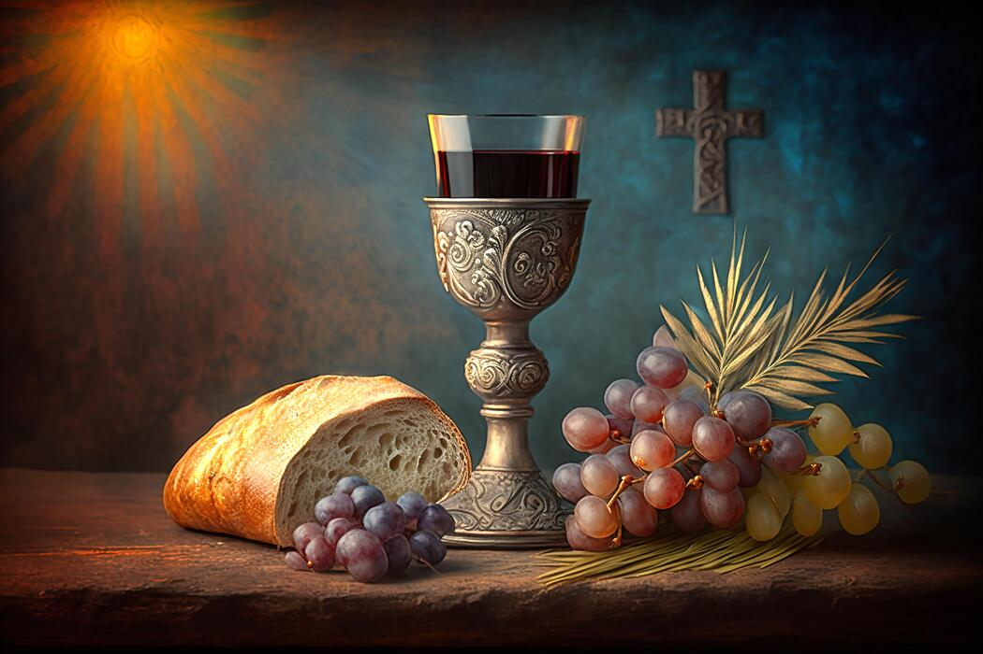

Yorkshire United Methodist Church
125 Edgewood Road
York, PA 17402
717-755-4952
www.yorkshirechurch.org

“Biblically Speaking”

