The Great Festival of Easter
Yorkshire United Methodist Church
April 5, 2026 10:00 AM

PREPARATION for WORSHIP
The Pre-service Concert The Brass Quartet

The Choral Introit

Welcome to Worship
(We bid special welcome to our guests today and encourage you to complete
a visitor’s card as found in the pew. We would be glad to contact you if you
wish. Thank you for being with us today as we worship God.)

A Moment of Friendship

WORSHIP through PRAISE
The Call to Worship “Holy Forever”

The Bidding Prayer

*The Hymn of Praise “Christ the Lord is Risen Today” No. 302
(We will sing all verses)
OUR CALL to PRAYER and PRAISE
Leader: They were looking for a dead friend, mourning a loss;
caught up in grief; worrying about stone-cold tombs.
People: They were prepared for death; not for life. They were
ready for sadness, but not for joy.
Leader: Easter turned it around! Turned the world upside
down. Love is on the throne, hope on the horizon, and
joy is possible in spite of our troubles.
People: Easter turns darkness around; makes our lives
different; renews our hope; fills us with courage; and
gives us a new song to sing.

A Time of Silent Prayer and Meditation

Our Prayer of Confession
We know, O God, that the good news of the resurrection is not
to be kept a secret, hidden away as the private promise to a few.
Rather it is to be a universal communication of hope and joy to
all people. Where we have failed in our commitment to make
your eternal love known to all the world, we now ask your
forgiveness, and pray that through your Holy Spirit we may
rededicate ourselves to this task. Amen.

A Song of Prayer and Praise “I Know a Name”

The Prayers of Our People and Pastoral Prayer

The Morning Anthem “Do You Know He’s Arisen?”
and Terry Randolph, arr. Matt Hochmiller
Our WORSHIP through Giving
Our Worship with Gifts of Tithes and Offerings
The Call
The Prayer of Dedication
The Offertory The Brass Quartet

WORSHIP through PROCLAMATION OF THE WORD
The Scripture Lesson Luke 24:1-12

The Hymn of Preparation “Easter People, Raise Your Voices” No. 304

The Sermon The Swing of Emotion that is Easter

*The Hymn of Dedication “The Day of Resurrection” No. 303

*The Benediction and Postlude “He Is Lord-Shout On”

Thanks to all who made Holy Week a special time of remembrance. Musicians, vocalists, those who provided and arranged for the placement of Lilies, Palms and Palm Crosses, the Children in their parade of Palms, those who prepared for Holy Communion for Maundy Thursday, our faithful technology crew and, as always, our faithful office and custodial staff. Where would we be without everyone’s help? Thanks to all.

The powerful music of Easter has been made even more powerful by the participation of the members of the brass quartet. They are Nick Berger of Dover, Jose Johnson of Lancaster, A.J. Myers of York, and J.D. McKelvey of Palmyra. We are so grateful that they could join us from near and far to add to the inspiration of this day. Thank you friends!



The Altar Flowers are presented in celebration
of our sons’ and their wives’ birthdays:
Joshua (3/20), Jamie (4/27)
Andrew (4/9), Caroline (3/17)

Please keep Pastor Roger in your prayers as he undergoes surgery on April 7th.

THIS WEEK:
Monday
Church Office Closed

Tuesday
Preschool Open House 5:30pm

Wednesday
“Men at the Sixes,” @6am - Fellowship Hall
Bible Study @6pm in the Youth Room

Thursday
Prayer Breakfast @8am- Two Brothers Restaurant
Choir @6:15pm in the Music Room

Saturday
Mulch Delivery & Outside Work Day – 9am

UPCOMING EVENTS:
Apr 6th – Easter Holiday – Church Office Closed
Apr 7th – Preschool Open House 5:30-7:30pm
Apr 11th – Outside Workday & Mulch Delivery – 9am

Healthy Kids Running Series – 4-5pm on:
Apr 12, April 19, April 26, May 10, and May 17th

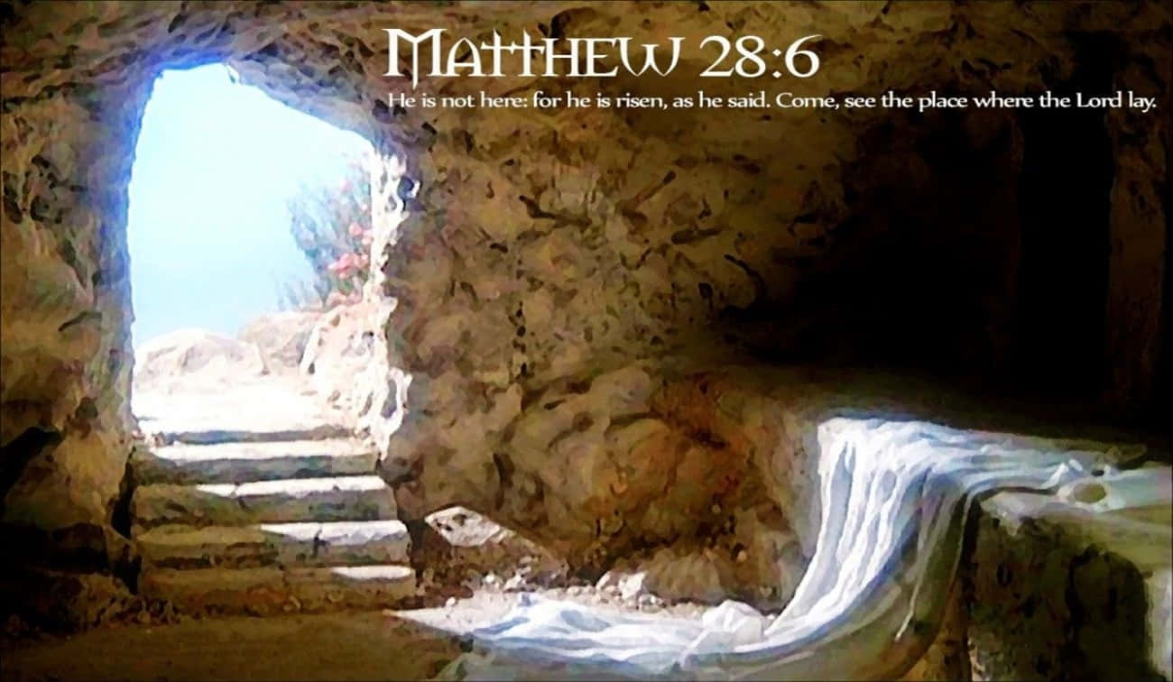

Yorkshire United Methodist Church
125 Edgewood Road
York, PA 17402
717-755-4952
www.yorkshirechurch.org

“Biblically Speaking”

