The Second Sunday of Lent
contemporary service
March 1, 2026 - 9:00 AM

Call to Worship Video

Welcome and Announcements

The Bidding Prayer

*Opening Song

Our Prayers

*A Song of Praise and Preparation

Our Worship with Gifts of Tithes and Offerings
The Call
The Prayer of Dedication
Special Music

The Scripture Lesson
Psalm 62: 5-8
Matthew 16: 13-18

Sermon
“I Am On the Rock”

Children’s Message

The Sacrament of Holy Communion

*Closing Song

*Benediction

Jazze Palmer, Musician

*Please stand as you are able

Jazze Palmer, Musician

The Second Sunday of Lent
Traditional Service
March 1, 2026 - 11:15 AM

PREPARATION for WORSHIP

The Prelude “When I Survey the Wondrous Cross”
Hamburg and Rockingham

The Choral Introit

Welcome to Worship
(We bid special welcome to our guests today and encourage you to complete
a visitor’s card as found in the pew. We would be glad to contact you if you
wish. Thank you for being with us today as we worship God.)

WORSHIP through PRAISE
The Call to Worship “Lord Who Throughout These 40 Days”
First Verse Only No. 269
The Bidding Prayer

*The Hymn of Praise “My Hope is Built” No. 368

The Call to Prayer and Praise
-Adapted from Robert Winterhalter with George W. Fisk, Jesus'
Parables: Finding Our God Within (NY: Paulist Press, 1993).
Leader: We rejoice in the vision of God completing the divine
work in and through us.
People: We rejoice in the vision of God that we are allowed
to complete God’s work here and everywhere,
serving all people as we can.
Leader: We rejoice in the indwelling Christ, working within our
souls toward wholeness, harmony and well-being.
All: We agree with the indwelling action of God bringing
order, harmony and fulfillment into all our
experiences.

A Time of Silent Prayer and Meditation

Our Prayer for Greater Discipleship
Lord, I would be as you are: Give me your obedient heart.
You offer pity, mercy, and are always kind; let me have your

loving mind. Teach us, good Lord, to serve you as you deserve;
to give and not to count the cost; to fight and not to heed the
wounds; to work and not to seek for rest; to labor and not to ask
for any reward, except that of knowing that we do your will;
through Jesus Christ, our Lord. Amen.

The Hymn of Prayer “Pass It On” No. 572

The Prayers of Our People and Pastoral Prayer

Our Worship with Gifts of Tithes and Offerings
The Call
The Prayer of Dedication
The Offertory “You Are The Rock of My Salvation”

The Morning Anthem

WORSHIP through PROCLAMATION OF THE WORD
The Scripture Lesson Psalm 62: 5-8
Matthew 16: 13-18

The Sermon “I Am On The Rock”

The Hymn of Preparation “Let Us Break Bread Together”
No. 618
Children’s Message

The Sacrament of Holy Communion

*The Hymn of Dedication “Rock of Ages, Cleft for Me” No. 361

*The Benediction and Postlude “I Will Call Upon the Lord”

Beth Gross, Organist


The Altar Flowers are
presented by Yorkshire Church
to the Glory of God.

THANK YOU to Pastor Bish for filling in for us today while Pastor Roger is on vacation!

SUB SALE! The Preschool is hosting a sub/sandwich sale through March 9th. Delivery is March 19th. Order forms are in the narthex. Thank you for your support!

EASTER FLOWERS: Order forms for Easter Flowers are in the narthex. Please fill out the form & place it in the offering plate with your payment. Checks can be made out to Yorkshire Church. The deadline for orders is March 15, 2026. Please contact the church office with any questions.

MULCH SALE: Boy Scout Troop 25 Annual Mulch Sale has begun. Order forms are in the narthex. Orders are due by Mar 20th and delivery is on Apr 11th.

OUR PRESCHOOL IS GROWING! With growing comes the need for additional teachers. We are looking for the following:
4’s – Teacher – M, W, F 8:30-1pm – Must have teaching experience. We’d love to have you as part of the team. Contact the church if you or someone you know is interested in this position.

THIS WEEK:
Monday
- Women’s Bible Study @7pm - Fellowship Hall
Wednesday
- “Men at the Sixes,” @6am - Fellowship Hall
- Bible Study @6pm in the Youth Room
Thursday
- Prayer Breakfast @8am - Two Brothers Restaurant
- Choir @6:15pm in the Music Room
Saturday
- Preschool Open House 10-12pm

UPCOMING EVENTS:
Feb 23rd-Mar 25th – Pastor Roger vacation
- March 1st – Pastor Bud Bish
- March 8th – Pastor Vizthum
- March 15th – Rev Zeiders
- March 22nd – Pastor Barnet
Mar 7th – Preschool Open House 10-12pm
Mar 9th – Preschool Sub Sale Ends
Mar 12th – Family Fun Night – 6-7:15pm
Mar 15th – Easter Flower Orders Due
Mar 19th – Preschool Sub Delivery
Mar 20th – Mulch Orders Due
Mar 21st – Easter Egg Hunt 10-1pm
Mar 29th – Palm Sunday
Apr 2nd – Maundy Thursday Service @7pm
Apr 3rd – Good Friday Service @7pm
Apr 5th – Easter
Apr 6th – Easter Holiday – Church Office Closed
Apr 7th – Preschool Open House 5:30-7:30pm
Apr 11th – Outside Work Day & Mulch Delivery @9am
Healthy Kids Running Series – 4-5pm on the following dates:
Apr 12, April 19, April 26, May 10, and May 17th

Church Staff
Roger Mentzer, Pastor
Stacey Roache, Administrative Assistant
Jazze Palmer, Contemporary Musician
Matthew Hochmiller, Choir Director
Jackie Linsey, Organist
Beth Gross, Organist
Chris Bare, Custodian
Julie Mann, Preschool Director

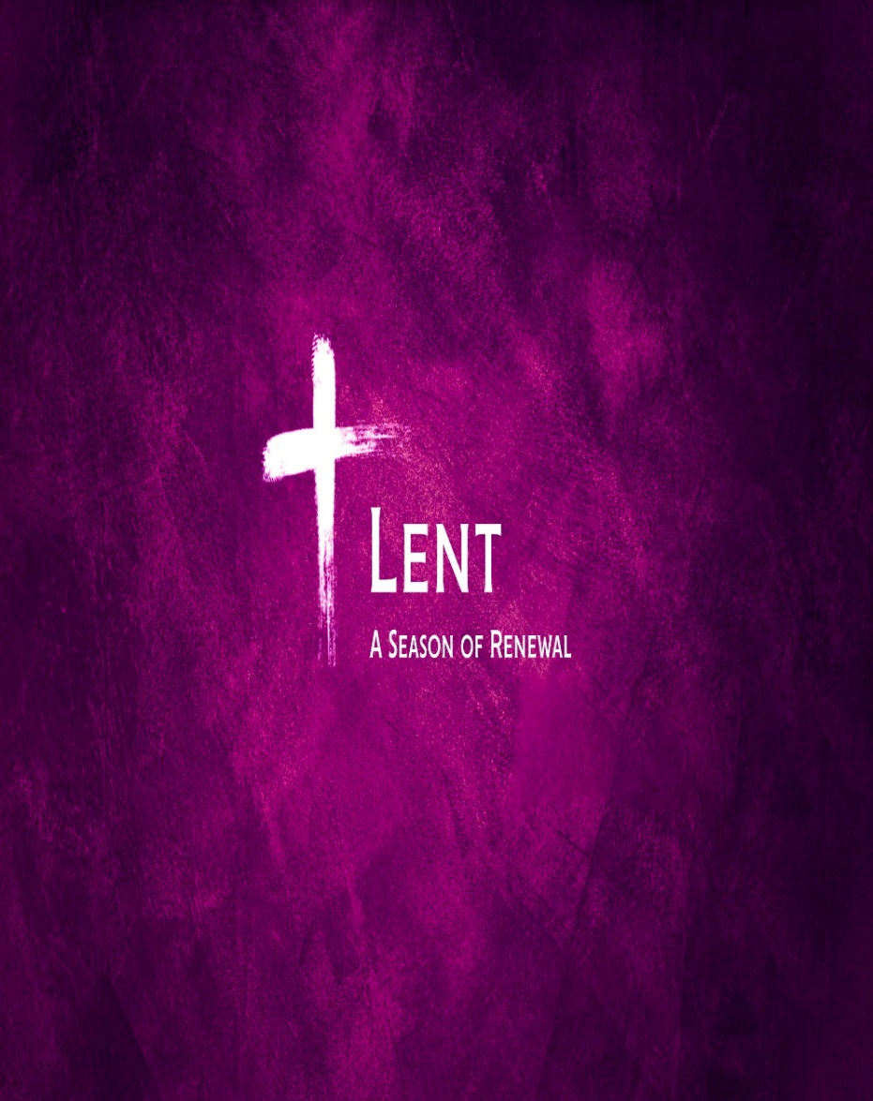

Yorkshire United Methodist Church
125 Edgewood Road
York, PA 17402
717-755-4952
www.yorkshirechurch.org

“Biblically Speaking”

