Ash Wednesday
February 18, 2026
A Service of Repentance, Washing, and Holy Communion

The Prelude Prelude On “Were You There”

The Welcome and Call of Lent

*The Hymn of Praise “Spirit Song” No. 347

The Call to Worship
Leader: Come, young and old. Give yourselves to God that you may
be sanctified, made holy before the Lord.
People: We gather to hear the word of God.
Leader: Come, and do not delay. Return to God.
People: We gather to be in the presence of God.
Leader: Come, cry out to God. Trust in God’s mercy.
People: We gather to find the renewal of our spirit, as we
acknowledge our failings before God.

A Time of Confession and Penitence
Leader: We turn to you, God of life, on this first day of Lent as we
recall our own mortality. With hearts torn open by our
actions, we need your guidance and your healing forgiveness.
Ready us to receive your mercy and grace, and cleanse us of
the ash of human failing, that we may embrace the words you
speak—the words that lead to eternal life. Amen.
To all of you I say: In preparation, present yourselves before God.
Come in your brokenness, acknowledging where you have fallen
short of God’s expectations and your own.
(Pause for silent reflection.)
Come in your pain, acknowledging your hurt and how you have hurt
others. (Pause for silent reflection.)
Come in your weakness, acknowledging your lack of strength and
confidence to always do what is right. (Pause for silent reflection.)
Come in your fear, acknowledging your failure to speak up for
justice. (Pause for silent reflection.)
Come in your hesitancy, acknowledging your resistance to God’s call.
(Pause for silent reflection.)
Come in your sinfulness, acknowledging what you have done and left
undone. (Pause for silent reflection.)
All: My brokenness that hinders me I lay before you. All the pain I have
in my life, that which I have caused and that which I feel, I lay before
you. The weakness that holds me captive I lay before you. My fear
that binds me I lay before you. My hesitancy in doing your will I lay
before you. The sin, which breaks my heart and leaves me lifeless, I
lay before you. Relieve us from these burdens we pray. Amen.

THE MARK OF DEATH
The Homily

The Introduction to the Imposition of Ashes
Leader: The Apostle Paul writes: “We entreat you on behalf of
Christ, be reconciled to God. For our sake [God] made him
to be sin who knew no sin, so that in him we might become
the righteousness of God. As we work together with him,
we urge you also not to accept the grace of God in vain.”
Ash is a traditional sign of repentance, contrition, and sin.
Tonight, the mark of the cross is made upon your foreheads
in ash: a sign of our desire to be reconciled with God.
Come before God.
People: We come confessing our sins. We come acknowledging
our need. We come facing our own death. We come
ready to receive God’s forgiveness and new life.
(Here the ushers will distribute containers filled with ashes. Each
person who desires may take a pinch or touch your finger to the
ashes and with the ash, mark his/her forehead with the sign of the
cross, signifying that “you are dust, and to dust you shall return.” As
the ashes are passed among us, we will join in singing the hymn.)

The Hymn “Were You There?” No. 288
(We will sing all verses as we remain seated)

THE MARK OF REPENTANCE
IN THE REMEMBRANCE OF BAPTISM

The Scripture Isaiah 58:1-12

The Homily

The Hymn “Sing, My Tongue, the Glorious Battle” No. 296

The Cleansing with Water
(Here each person who wishes may come, as the Spirit moves, to the
chancel area, take a towel, dip in the water provided, and wash the
ashen mark from your forehead. This will symbolize the remembrance
of your baptism and serve to affirm that covenant once again. You may
say to yourself, “I am a baptized Christian, in the name of the Father,
Son, and Holy Spirit. Amen”)
(For those not baptized, as you do this, imagine in your life the power
of God to wash away our sins, to cast them as far as the east is from the
west and remember them no more.)
(During this time of movement, the organ will play, encouraging your
meditation on the death and resurrection of Jesus Christ, by which He
redeemed you. Give thanks.)

The Evening Offering “Ashes”
The Prayer of Dedication
The Offertory Anthem “Depth of Mercy” Charles Wesley

THE MARK OF REBIRTH IN CHRIST…
THE GIFT OF GOD REMEMBERED IN HOLY COMMUNION

Leader: The Lord be with you.
PEOPLE: AND ALSO WITH YOU.
Leader: Lift up your hearts.
PEOPLE: WE LIFT THEM UP TO THE LORD.
Leader: Let us give thanks to the Lord our God.
PEOPLE: IT IS RIGHT TO GIVE OUR THANKS AND PRAISE

The Prayer of Thanksgiving and Institution

The Invitation
(You will be asked to come forward to receive the bread and the cup
in this act of faith. The ushers will excuse you at the proper time.
They will serve those who might be unable to come forward)
*The Hymn of Dedication “Beneath the Cross of Jesus” No. 297

*The Benediction and Postlude Benedictus on "Sicilian Mariners"

Beth Gross, Organist
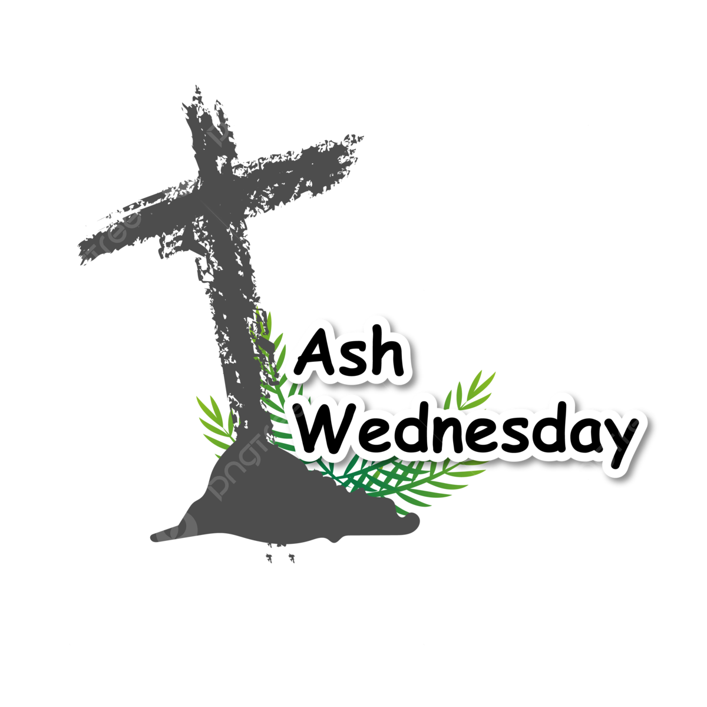

Yorkshire United Methodist Church
125 Edgewood Road
York, PA 17402
717-755-4952
www.yorkshirechurch.org

