The Second Sunday After Epiphany
Contemporary Service
January 18, 2026 - 9:00 AM

Call to Worship Video

Welcome and Announcements

The Bidding Prayer

*Opening Song

Our Prayers

*A Song of Praise and Preparation

Our Worship with Gifts of Tithes and Offerings
The Call
The Prayer of Dedication
Special Music

The Scripture Lessons
Daniel 6:10
Psalm 5:1-3

The Sermon
The Circle Maker:
Think Long – Pray Long

*Closing Song

*Benediction

*Please stand as you are able

Jazze Palmer, Musician

The Second Sunday after Epiphany
January 18, 2026 - 11:15 AM

PREPARATION for WORSHIP

The Prelude Prelude on "Slane"

The Choral Introit “Sweet Hour of Prayer”

Welcome to Worship
(We bid special welcome to our guests today and encourage you to complete
a visitor’s card as found in the pew. We would be glad to contact you if you
wish. Thank you for being with us today as we worship God.)

WORSHIP through PRAISE
The Call to Worship “Seek Ye First” No. 405

The Bidding Prayer

*The Hymn of Praise “Joyful, Joyful, We Adore Thee” No. 89

The Call to Prayer and Praise
Leader: We have come here to testify to your love; Come to us,
living God, and shine your light in our darkness.
People: We have seen your glory, full of grace and truth; Come
to us, living God, and shine your light in our darkness.
Leader: From your fullness we have received every grace; Come
to us, living God, and shine your light in our darkness.

A Time of Silent Prayer and Meditation

Our Prayer for Greater Discipleship
Holy God, there is within us a deep desire to know you -- to
rest in your presence, to trust in your mercy, to feel your loving
embrace envelop us. And so, we search here and there… and
all the while, you wait patiently and quietly for us to return
home. You have been with us all along, calling us, wooing us,
guiding us. The voice we drowned out with the noise of our lives
was yours, but you have never stopped speaking. It is in
worship, gracious God, that we are reminded to slow down, to
be still and silent, and to listen. Thank you for this sacred time
and space, and we ask that you make yourself known to us
anew. For the sake of Christ we pray. Amen.

The Hymn of Prayer “How Can We Name a Love” No. 111

The Prayers of Our People, Pastoral Prayer, and Lord’s Prayer

The Morning Anthem “Praise to the Lord, The Almighty”
McDonald

Our Worship with Gifts of Tithes and Offerings
The Call
The Prayer of Dedication
The Offertory “Give Thanks”

WORSHIP through PROCLAMATION OF THE WORD
The Scripture Lessons Daniel 6:10
Psalm 5:1-3

The Hymn of Preparation “And Can It Be” No. 363
(We will sing verses 1-4 only)

The Sermon Be a Circle Maker: Think Long – Pray Long

*The Hymn of Dedication “O Jesus I Have Promised” No. 396

*The Benediction and Postlude
Wie Schon Leuchtet der Morgenstern

Beth Gross, Organist

The Altar Flowers are presented by Yorkshire United Methodist Church to the Glory of God!

NEW MEMBERS: Persons who have been visiting with us are invited to join Yorkshire Church on Sunday, January 25. If you are interested, please write a note or email to Pastor Roger at rmentzer@susumc.org, send a text me to 717-870-8212, or speak with him in person at your earliest convenience. Even if you don’t join, we are delighted you are here in worship and invite you to participate in any activity of interest to you. Our task is to make and grow Disciples of Jesus Christ. We are glad you are with us.

YOUTH RETREAT: The Zeteo Youth Retreat will be held Jan 30th-Feb 1st. Donations are needed for snacks/meals. Please see the sign-up sheet in the narthex or contact Joe Blackwood with questions.

Volunteers needed! We are looking for volunteers to make Zippy Beef Casseroles. The Sign-Up sheet along with recipe and ingredients is in the narthex. Sign-Up for the month of February!

SUPPORT OUR YOUTH GROUP: Provide a meal for our youth prior to their meeting. You may either make or buy a meal. Sign-up sheet in the narthex. For more information, please speak with Joe Blackwood at 704-591-1252.

NEW! Online giving cards are in the pews. Please place the card in the offering plate indicating your electronic giving and participation in this act of worship.
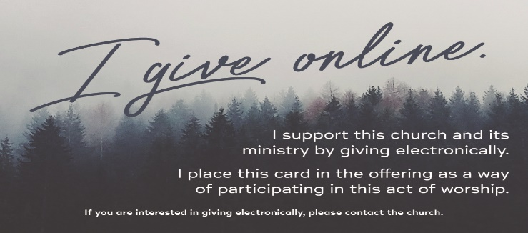

THIS WEEK:
Monday Evening – The Women’s Bible Study meets at 7pm in the Fellowship Hall.

Wednesday Morning – The Men’s Group – “Men at the Sixes,” meets at 6am in the Fellowship Hall.

Wednesday Evening – Bible Study meets at 6pm in the Youth Room.

Thursday Morning –Prayer Breakfast meets at 8am at Two Brothers Restaurant, 2935 E. Prospect Road.

Thursday Evening – The Chancel Choir meets at 6:15 in the Music Room. Come add your voice.

UPCOMING EVENTS:
Jan 19th - Women’s Bible Study “The Way of Wisdom” @7pm
Jan 27th - Administrative Council Mtg @6pm
Jan 30th - Zeteo Youth Retreat
Feb 1st-Preschool registration opens for 2026-2027 school year
Feb 5th - Preschool Open House 5:30pm-7:30pm
Save the Date - Sat., March 21st 10-1pm – Easter Egg Hunt


INCLEMENT WEATHER:

With winter here please keep in mind that delays/closings will be posted on WGAL “Closings” website and displayed on WGAL TV.

Yorkshire United Methodist Church
125 Edgewood Road
York, PA 17402
(717) 755-4952

“Biblically Speaking”
Church Staff
Roger Mentzer, Pastor
Stacey Roache, Administrative Assistant
Jazze Palmer, Contemporary Musician
Matthew Hochmiller, Choir Director
Jackie Linsey, Organist
Beth Gross, Organist
Chris Bare, Custodian
Julie Mann, Preschool Director

