The First Sunday After Epiphany
Contemporary Service
January 11, 2026 - 9:00 AM

Call to Worship Video

Welcome and Announcements

The Bidding Prayer

*Opening Song

Our Prayers

*A Song of Praise and Preparation

Our Worship with Gifts of Tithes and Offerings
The Call
The Prayer of Dedication
Special Music

The Scripture Lessons
Numbers 11:4-6, 21-23, 31-32
Acts 10:1-5

The Sermon
The Circle Maker:
Dream Big

*Closing Song

*Benediction

*Please stand as you are able

Jazze Palmer, Musician

The First Sunday after Epiphany
Traditional service
January 11, 2026 - 11:15 AM

PREPARATION for WORSHIP

The Prelude “In Christ There is No East or West”

The Choral Introit

Welcome to Worship
(We bid special welcome to our guests today and encourage you to complete
a visitor’s card as found in the pew. We would be glad to contact you if you
wish. Thank you for being with us today as we worship God.)

WORSHIP through PRAISE
The Call to Worship “Seek Ye First” No. 405

The Bidding Prayer

*The Hymn of Praise “How Great Thou Art” No. 77

The Call to Prayer and Praise
Leader: We are called to bring a new understanding of God:
that God so loves the world.
People: We are the salt of the earth, called to bring a new
hope in God: that God gives us new life. We are the
light of the world, called to follow the
commandments and the law.
Leader: The law of God is to love God and to love one another.
Come, let us be the salt of the earth, the light of the
world. Let us love one another with the love of God.
People: Let us join together in our love of God to worship
and follow Jesus.

A Time of Silent Prayer and Meditation

Our Prayer of Confession
In the stillness of this time and place, let us think not on what
we have done, but on what we have failed to do. O God, we are
sorry for the occasions when:
…we saw a life falling apart and failed to pray;
…we witnessed the beginnings of a childish meltdown and failed
to take the time to pray and bring a breath of calm reassurance;
…we didn't heed the warning for caution and instead plunged
willfully forward, without prayer, to the detriment of others;
…we have failed to surround our brothers and sisters in prayer
in their time of need;
…we acted irresponsibly, and prayerlessly, and others paid for
our costly arrogance.
Forgive us, loving God, for our failures of the past, and awaken
us to heed the challenges of the future. Make us a prayerful
people at every turn. Amen.

Words of Comfort, Assurance, and Instruction
Leader: My friends, hear this good news: God claims
you as His own. You are loved forever, no matter what
you have done or failed to do. You are granted newness
of life; rejoice in the assurance that, in the name of Jesus,
you are forgiven.
The Hymn of Prayer “Open My Eyes, That I May See” No. 454

The Prayers of Our People, Pastoral Prayer, and Lord’s Prayer

The Morning Anthem “My Tribute”

Our Worship with Gifts of Tithes and Offerings
The Call
The Prayer of Dedication
The Offertory

WORSHIP through PROCLAMATION OF THE WORD
The Scripture Lesson Numbers 11:4-6, 21-23, 31-32
Acts 10:1-5
The Hymn of Preparation “Be Thou My Vision” No. 451

The Sermon Be a Circle Maker: As You Pray - Dream Big

*The Hymn of Dedication “O Spirit of the Living God” No. 539

*The Benediction and Postlude “Help Us Accept Each Other”
Jackie Linsey, Organist

The Altar Flowers are presented by Lynn & Steve Spangler
in honor of the
family’s January birthdays.
Grandson Brendan (4th), Daughter-in-law Lauren (9th), Daughter Steph (12th),
Lynn (21st), and Mother Norma (26th).

RETURN TO FORMAL OFFERING TODAY: Due to the Covid Pandemic, the choice was made at Yorkshire Church to not make a formal offering as with passing the offering plates among those present. In the days of Covid, it made good sense as a protective health measure. As an alternative, we set up stands near the entrance of the lobby, with another near the entrance to the sanctuary. People would simply slide their offering into the slot-stands. We have also strongly encouraged persons to set up an Automatic Giving Plan with their bank, using “Stripe Payouts” so that contributions might take the form of online automatic payments. This is the ultimate in planned giving and we are grateful for those persons and families who have chosen this as a faithful practice. Others who are interested in this style may contact https://Yorkshire.churchcenter.com/giving. The slot-stands and online giving will be continued as a means of our giving for those who prefer them. However, at a recent meeting of our Leadership Council, after a review of our financial situation, it was determined that we should go back to our more formal style of giving, using the offering plates to be passed among us. This would do two things: First, it would help to increase the call to thankful and generous giving which is too easy to miss in the slot-stands and automatic payments. Second, there is a spiritual side to the blessedness of giving that is missed when we do not hear the call to give… a call that requires a response. That response is an act of worship. With the alternative means of giving, we miss that holy calling. Our current funding situation has led us to believe we have suffered a loss of funds over recent years as we made the change from a formal offering. All this said, however you give, it is blessed. But presenting our offerings to almighty God engages the importance of commitment to be a generous people. Please speak with Pastor Roger with questions.

INCLEMENT WEATHER:

With winter here please keep in mind that delays/closings will be posted on WGAL “Closings” website and displayed on WGAL TV.

YOUTH RETREAT: The Zeteo Youth Retreat will be held Jan 30th-Feb 1st. Donations are needed for snacks/meals. Please see the sign-up sheet in the narthex or contact Joe Blackwell with questions.

OUR DAILY BREAD: We are looking for volunteers to make Zippy Beef Casseroles. The Sign-Up sheet along with recipe and ingredients is in the narthex. Sign-Up for the month of February!

NEW MEMBER CLASS FORMING – Persons who have been visiting with us are invited to join Yorkshire Church on Sunday, January 25. If you are interested, please write a note, email rmentzer@susumc.org, or text to Pastor Roger at 717-870-8212 at your earliest convenience. Even if you don’t join, we are delighted you are here in worship and invite you to participate in any activity of interest to you. Our task is to make and grow Disciples of Jesus Christ. We are glad you are with us.

SUPPORT OUR YOUTH GROUP: Provide a meal for our youth prior to their meeting. You may either make or buy a meal. Sign-up sheet in the narthex. For more information, please speak with Joe Blackwood at 704-591-1252.


THIS WEEK:
Monday Evening – The Women’s Bible Study meets at 7pm in the Fellowship Hall.
Wednesday Morning – The Men’s Group – “Men at the Sixes,” meets at 6am in the Fellowship Hall.
Wednesday Evening – Bible Study meets at 6pm in the Youth Room.
Thursday Morning –Prayer Breakfast meets at 8am at Two Brothers Restaurant, 2935 E. Prospect Road. Please note the time correction.
Thursday Evening – The Chancel Choir meets at 6:15 in the Music Room. Come add your voice.

UPCOMING EVENTS:
Jan 13th - Preschool Board Mtg @630pm
Jan 17th - Sunday School Friendship Party from 11-1:30pm
Jan 19th - Women’s Bible Study “The Way of Wisdom” @7pm
Jan 27th - Administrative Council Mtg @6pm
Jan 30th - Zeteo Youth Retreat
Feb 1st - Preschool registration opens for 2026-2027 school year
Feb 5th - Preschool Open House 5:30pm-7:30pm
Save the Date - Sat., March 21st 10-1pm – Easter Egg Hunt

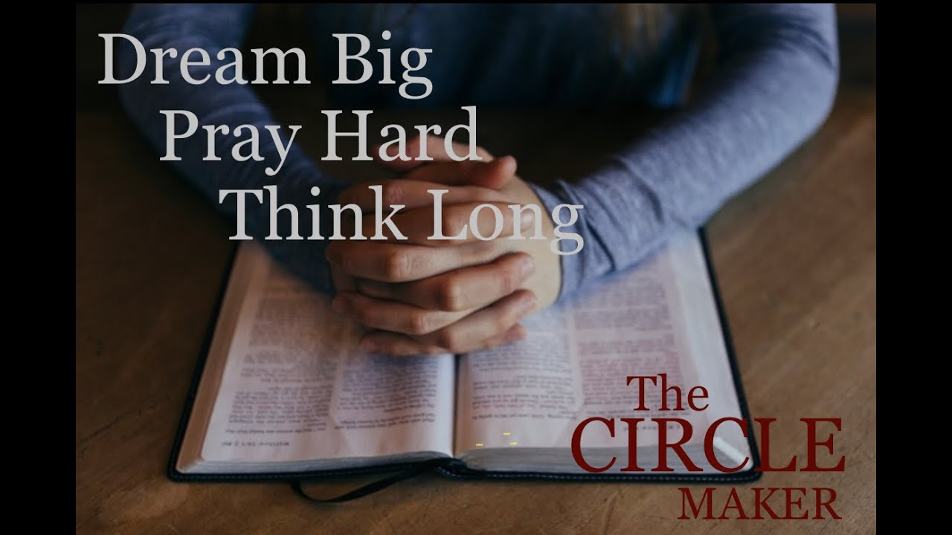

Yorkshire United Methodist Church
125 Edgewood Road
York, PA 17402
(717) 755-4952

“Biblically Speaking”

