What’s Brewing, Special Edition! FINANCE UPDATE
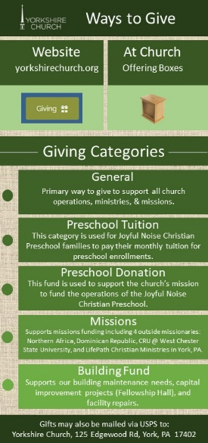
Good day Yorkshire! As we are closing the books for 2022, we are excited about the opportunities that we have for 2023. As you have seen over the past few weeks, we now include a “Ways to Give” insert in each week’s bulletin. This is for two purposes: 1) To be informative on how to give to Yorkshire Church as we depend on these gifts to finance our ministries, missions and operations, and 2) to provide info on where to give in each of the areas that the church serves. This year, we will be reporting our quarterly income requirements and gifts received for each of these giving categories. For example, the following represents our budget goals for each category for the first three months, or first quarter of 2023:
Giving Categories: 1st Quarter 2023 Budget
General: $105,000.00
Preschool Tuition: (not applicable to Yorkshire Church budget)
Preschool Donation: $ 1,008.00
Missions: $ 2,688.00
Building Fund: $ 7,280.00

At the end of each month, we will report the actual results we are achieving in each category. It is our hope that this information will be beneficial to you as you plan your giving. Our primary fund, as explained on the insert is our General Fund which covers all of our normal operating expenses. It is our hope that giving in the other categories does not reduce the income we need to carry out our daily needs such as salaries, utilities, routine building maintenance and our other various liabilities, but rather, is in addition to it.
In terms of the Building Fund, this is the amount of money that we committed to in order to finance the repairs and accessibility renovations to our fellowship hall. Our debt service each year is $26,000 which covers the payments to Traditions Bank. Your additional support in this area will help us to meet those obligations.
BUILDING FUND CHALLENGE!
We are pleased to announce that a friend of our fellowship, who has been very interested in the improvements that Yorkshire is making to its facility, has offered a Building Fund challenge for the month of January. This person, who wishes to remain anonymous, has pledged to match up to a total of $2,000.00 on any contributions that are received by the church during the month of January, 2023! We will report on this on a weekly basis during the month to let you know how the church has responded to this very generous offer!
Thanks again for all of your generous support to our fellowship. It is greatly appreciated and is allowing us to continue to pursue new ministries, missions and means to serve those who we are called to serve.

